Sharanya Garipally

Due Date: 24th March 2023

**Emergency Department Management database system**

Project 1

Table of Contents

Section 1: Introduction 2

Section 2: Functional Requirements 2

Section 3: Entity Relationships(Explaining with UML Diagram) 4

Section 4: Normalization 6

Section 5: SQL SCRIPTS 10

Section 6: ER Diagram 42

Section 7: Tool used : 44

# Section 1: Introduction

**Overview:**

Electronic Medical Records (EMRs) or Electronic Health Records (EHRs) are considered a critical technology for improving patient care quality and reducing health care cost. It should implement in every health center. For this project I specified data regarding patients in Emergency department.

From the personal experience I like when I visit any health center my details and my medical history to be populated automatically. It can help with tedious job to fill out application every time I visit a hospital. EMRs can be very useful not only for this but also capturing patient details digitally, prevention, treatment, and management of patients will become more evidence-based and personalized as data analytics discover more knowledge about the patient and the care process. The outcome will be more predictable, the process will be more efficient, and the overall healthcare system will be more effective.

**Database Design:**

Emergency Department Management database system is a computer base software system.it is designed to improve the quality and management of patients in emergency department.

The Emergency Department Management database system include the registrations of main 5 tables patients, doctors, Nurses, Receptionists and rooms and break down them into further tables with more details storing their details into system by using database. It gives unique ID to patients, doctors, Nurses, Receptionists and rooms to store their details.

With this management system data entry will become more efficient, easier to track, reduction of errors and no wastage of time.

Using this Database information about patients can be obtained like when a patient visit emergency every detail is captured digitally for example: Entry date, exit date, symptoms, Cure, which doctors is assigned, which nurse is treating, which room is available for them, how much bill they paid.

# Section 2: Functional Requirements

* **Entity Classes**

In this project there are 5 main entity classes. The details are described below:

1. **Doctor**

Doctor table store the data of the doctors who diagnose the patients.

1. **Nurse**

Nurse table stores the data of nurses who treats the patients.

1. **Patient**

Patient table stores the data of patients who takes appointment from reception.

1. **Reception**

Reception table stores the data of receptionist who interact with patient.

1. **Room**

Room table stores the record of which patients are admitted.

* Attributes

1. **Doctor**: Doctor table have 4 attributes:
2. Doctor_ID
3. Doctor _Name
4. Doctor_Specialization
5. Dr_AvailabilityStatus
6. Dr_AvailabilityDate
7. **Nurse:** Nurse table have 4 attributes:
8. Nurse_Name
9. Nurse_ID
10. Nurse_Address
11. Nurse_Email
12. **Patient**: Patient table have 7 attributes:
13. Patient_ID
14. Patient_Name
15. Patient_Gender
16. Patient_EntryDate
17. Patient_ExitDate
18. Doctor_ID
19. Nurse_ID
20. Receptionist_ID
21. Patient_address
22. **Receptionist:** Receptionist have 4 attributes:
23. Receptionist_ID
24. Receptionist_Name
25. Receptionist_Gender
26. Receptionist_Address
27. **Room**: Room table have 4 attributes:
28. Room_Number
29. Room_Availability
30. Room_EntryDate
31. Room_ExitDate

# Section 3: Entity Relationships(Explaining with UML Diagram)

1. Visit:

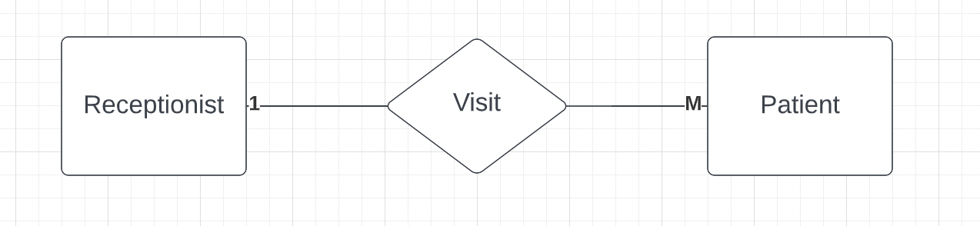

Type of relationship: One - To -Many[1:M]

* One receptionist delas many patients and one patient interact with only one Receptionist.
* Its an Association class

1. Diagnose:

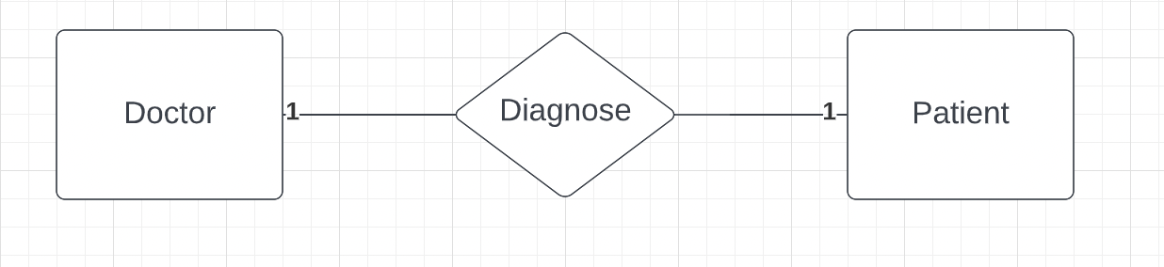

Type of relationship: One - To -One [1:1]

* One Doctor diagnoses only one patient and one patient can have only one doctor checked up at a time.
* Its an association class

1. Use:

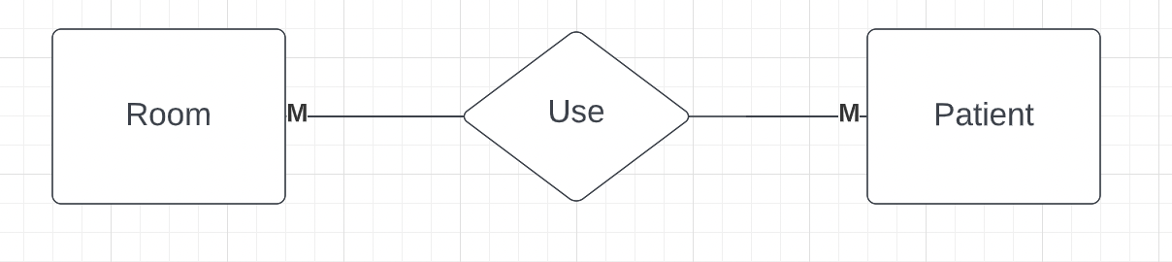

Type of relationship: Many - To -Many [M:M]

* One can admit in many rooms and one room can have many patients.

1. Treat:

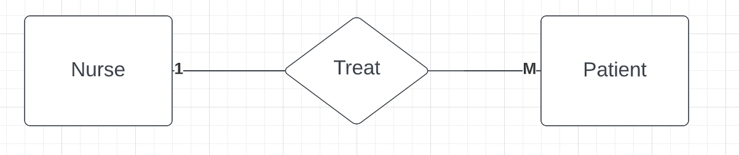

Type of relationship: Many - To -Many [M:M]

* One nurse can treat many patients and one patient treated by only one nurse.

Composition:

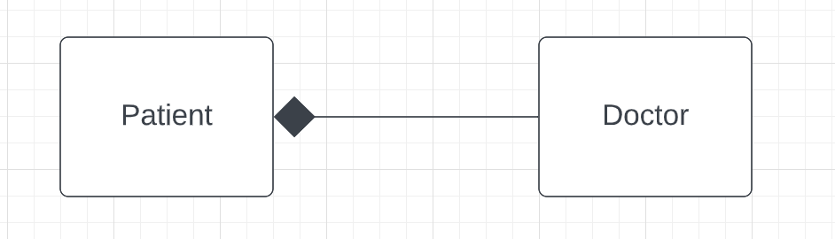

Composition: Every patient has a doctor

Aggregation:

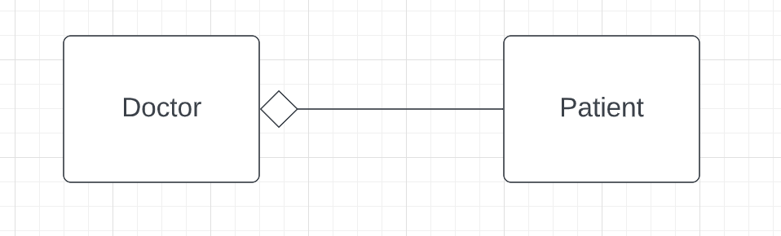

Aggregation: Doctors may have patients; they come and go.

Superclass, Subclass: Insurance is Superclass and InsuranceInfo is Subclass

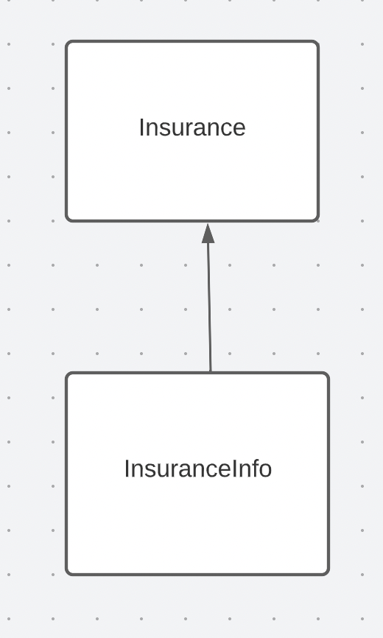

# Section 4: Normalization

1. Doctor table:

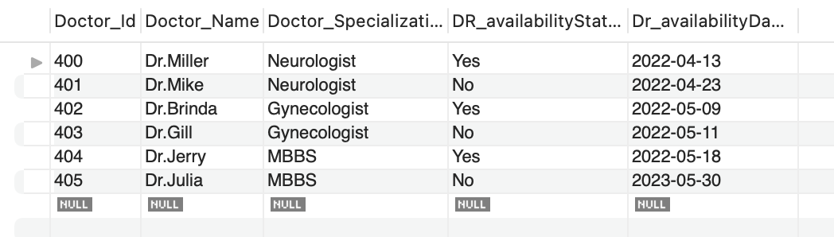

1. Nurse Table:

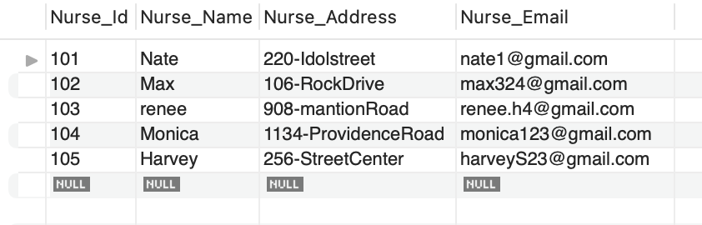

1. Room Table:

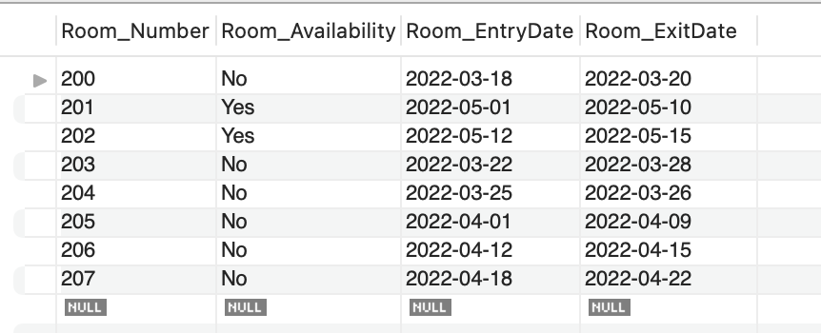

Receptionist Table:

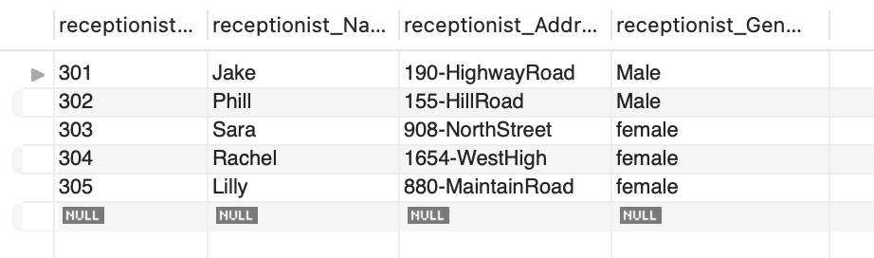

Patient Table:

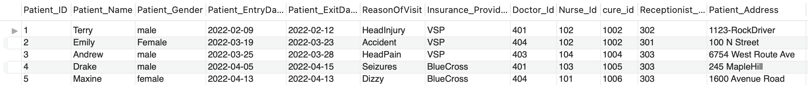

To make Patient Table in BCNF, Breakdown Patient table into further smaller tables like:

1. Visit Table:

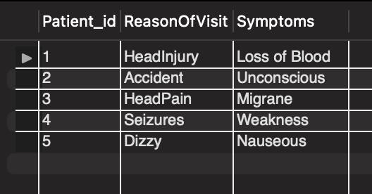

Visit Table is in BCNF

1. Insurance Table:

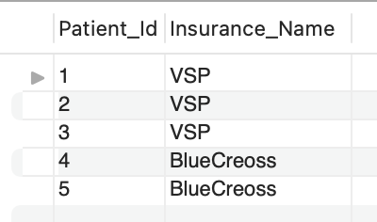

1. InsuranceInfo Table:

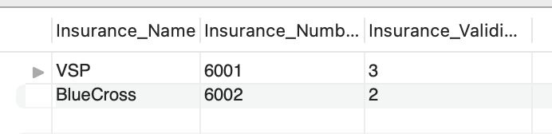

1. Cure Table:

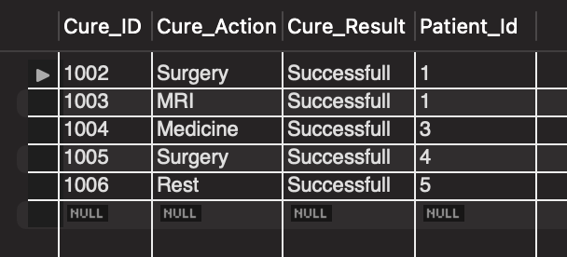

1. PatientAdmit:

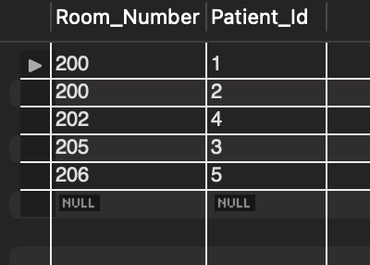

1. Payments table:

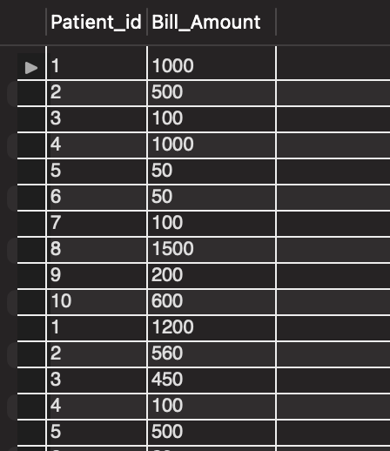

All Table are in BCNF as there are no partial dependency, no transitive dependency and left side column of functional dependency is a super Key.

New Tables Created are:

1. **Visit Table:** Which consists of Visit details of patients it consists of 3 columns:
2. Patient_Id
3. ReasonOfVisit
4. Symptoms
5. **Insurance Table:** Which says patient and their insurance provider names.
6. Patient_id
7. Insurance_Name
8. **InsuranceInfo:** consists of Insurance further details:
9. Insurance_Name
10. Insurance_Number
11. Insurance_validity
12. **Cure Table:** Consists of cure details for patients.
13. Patient_id
14. Cure_id
15. Cure_Action
16. Cure_Result
17. **PatientAdmit:** Consists of details for which patient’s rooms are assigned:
18. Patient_Id
19. Room_Number
20. **Payments:** consists of details of bill amount paid by patients:
21. Patient_id
22. Bill_Amount

# Section 5: SQL SCRIPTS

5

1. Select * from doctor;

Result:

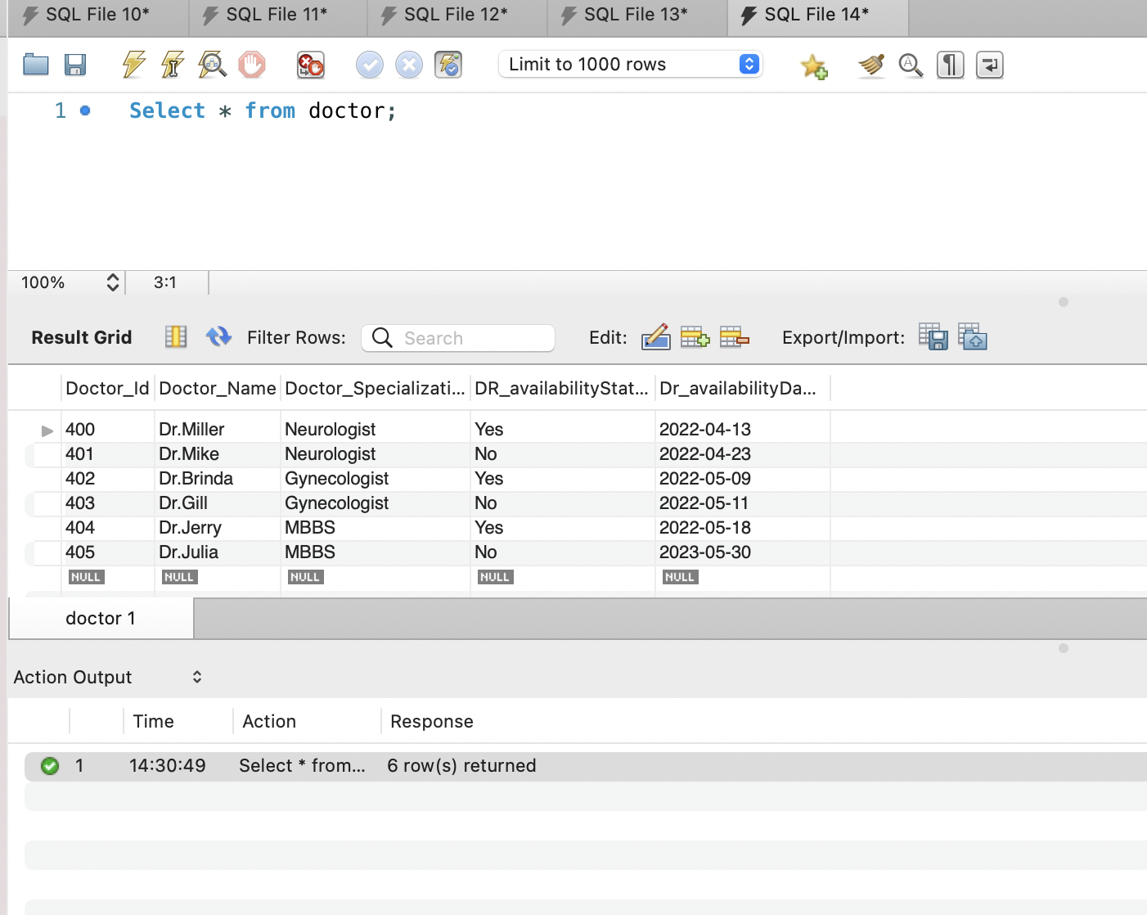

1. Select * from Nurse;

Result:

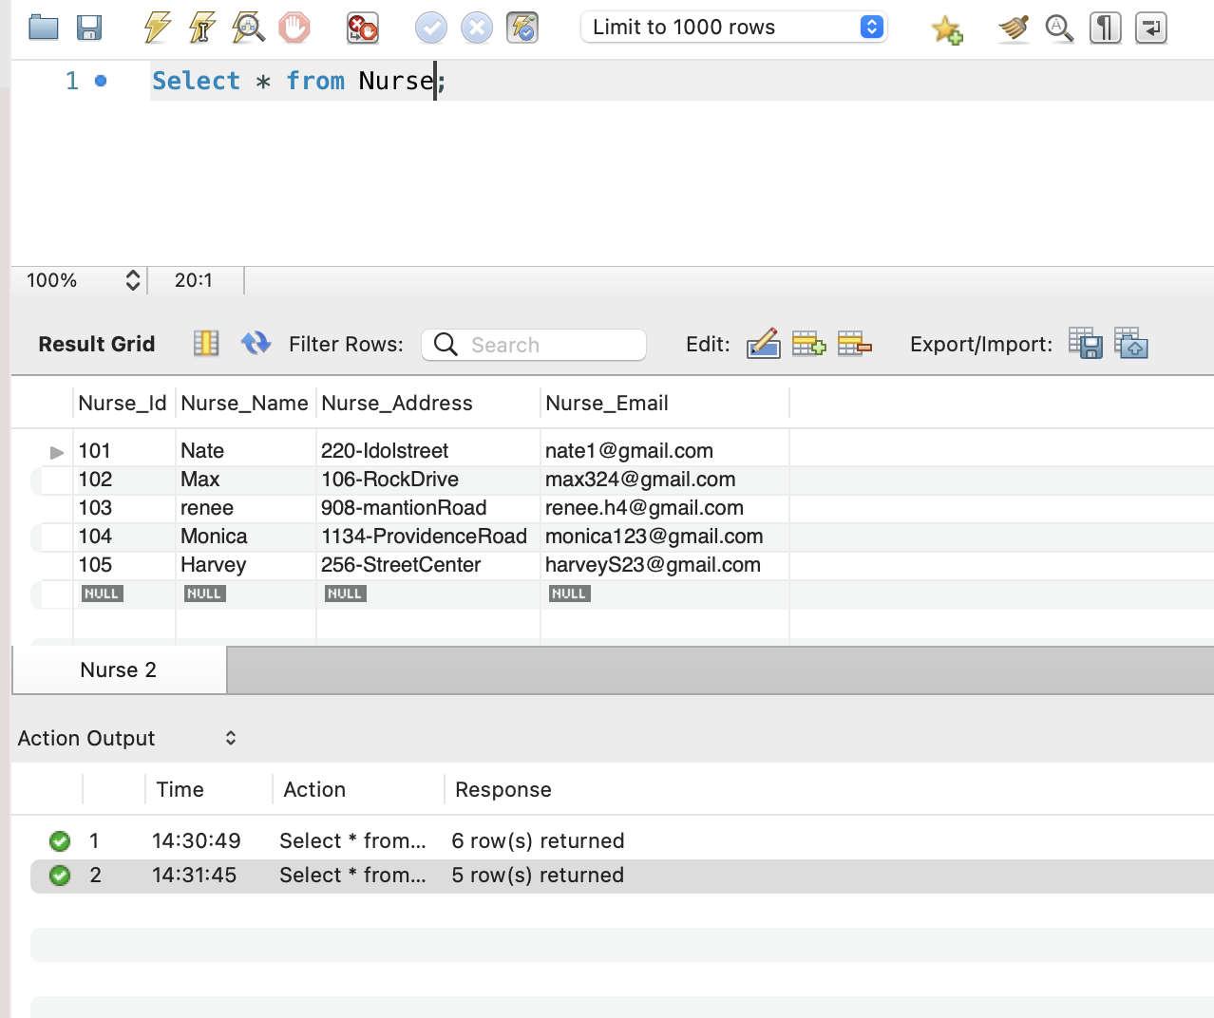

1. Select * from Room;

Result:

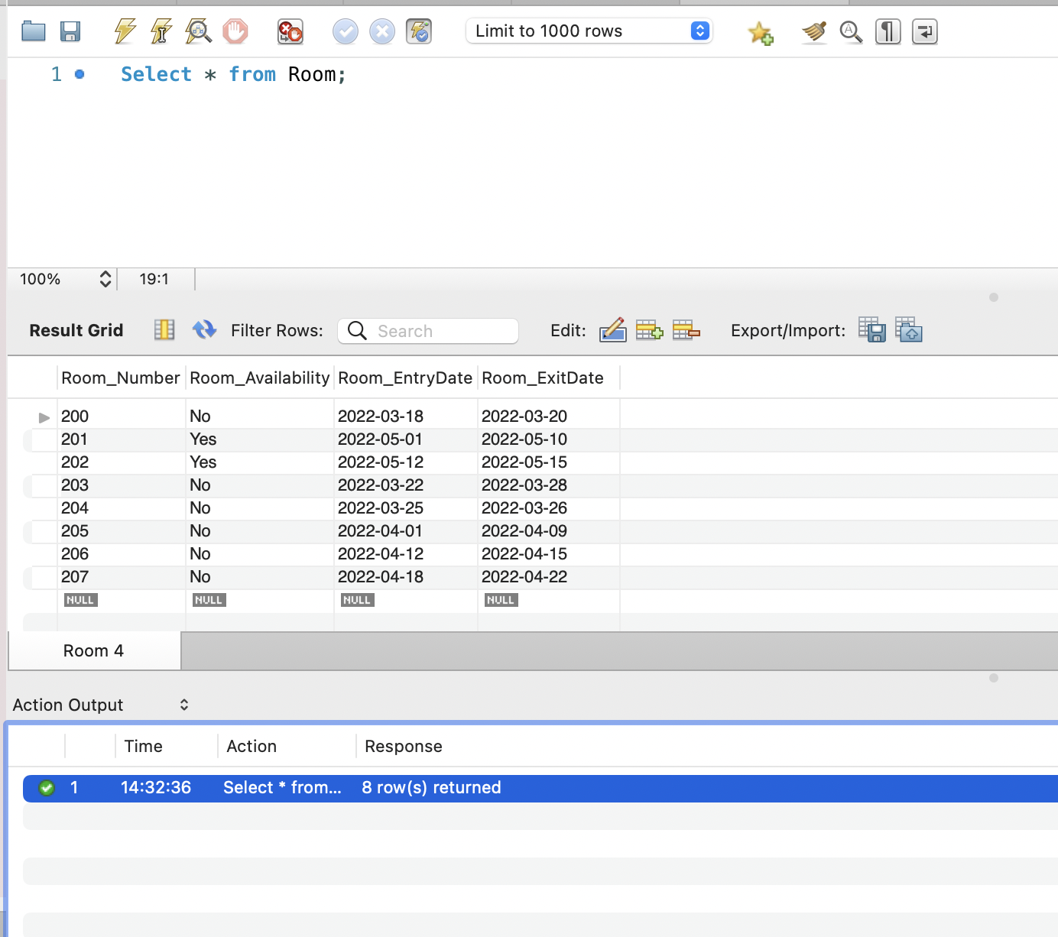

1. Select * from Receptionist;

Result:

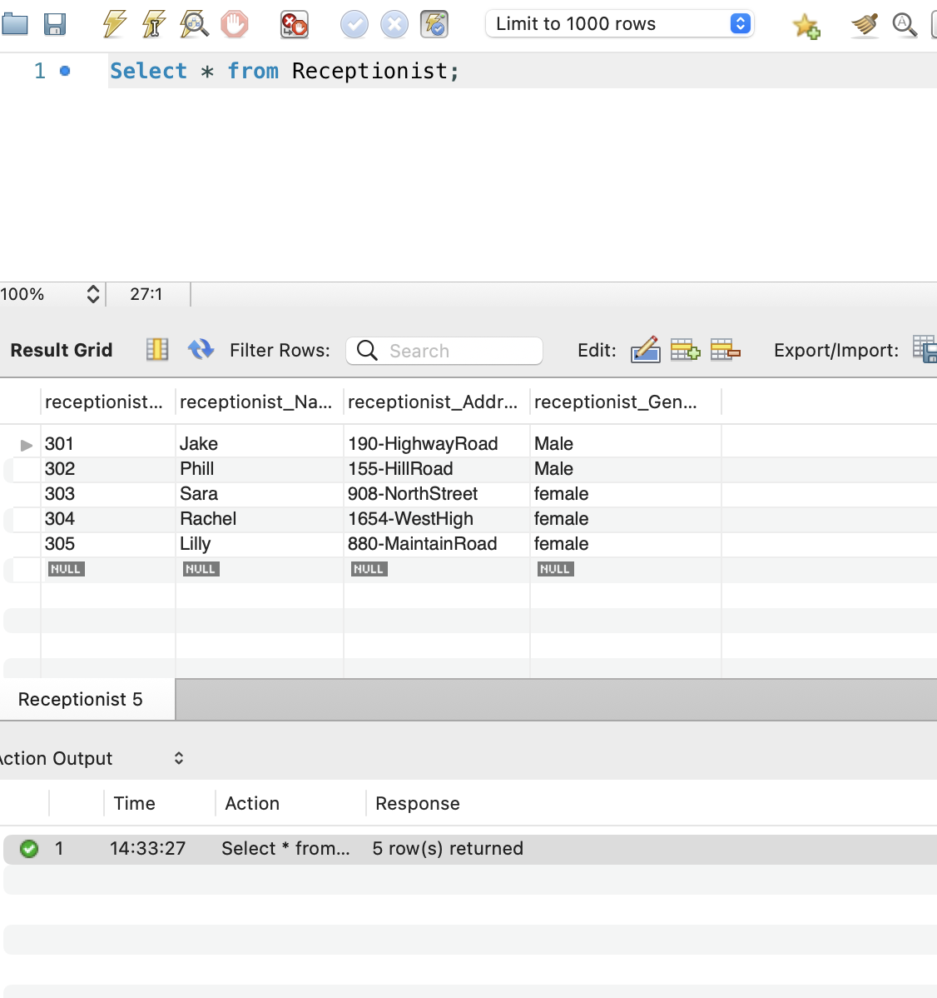

1. Select * from Patient

Result:

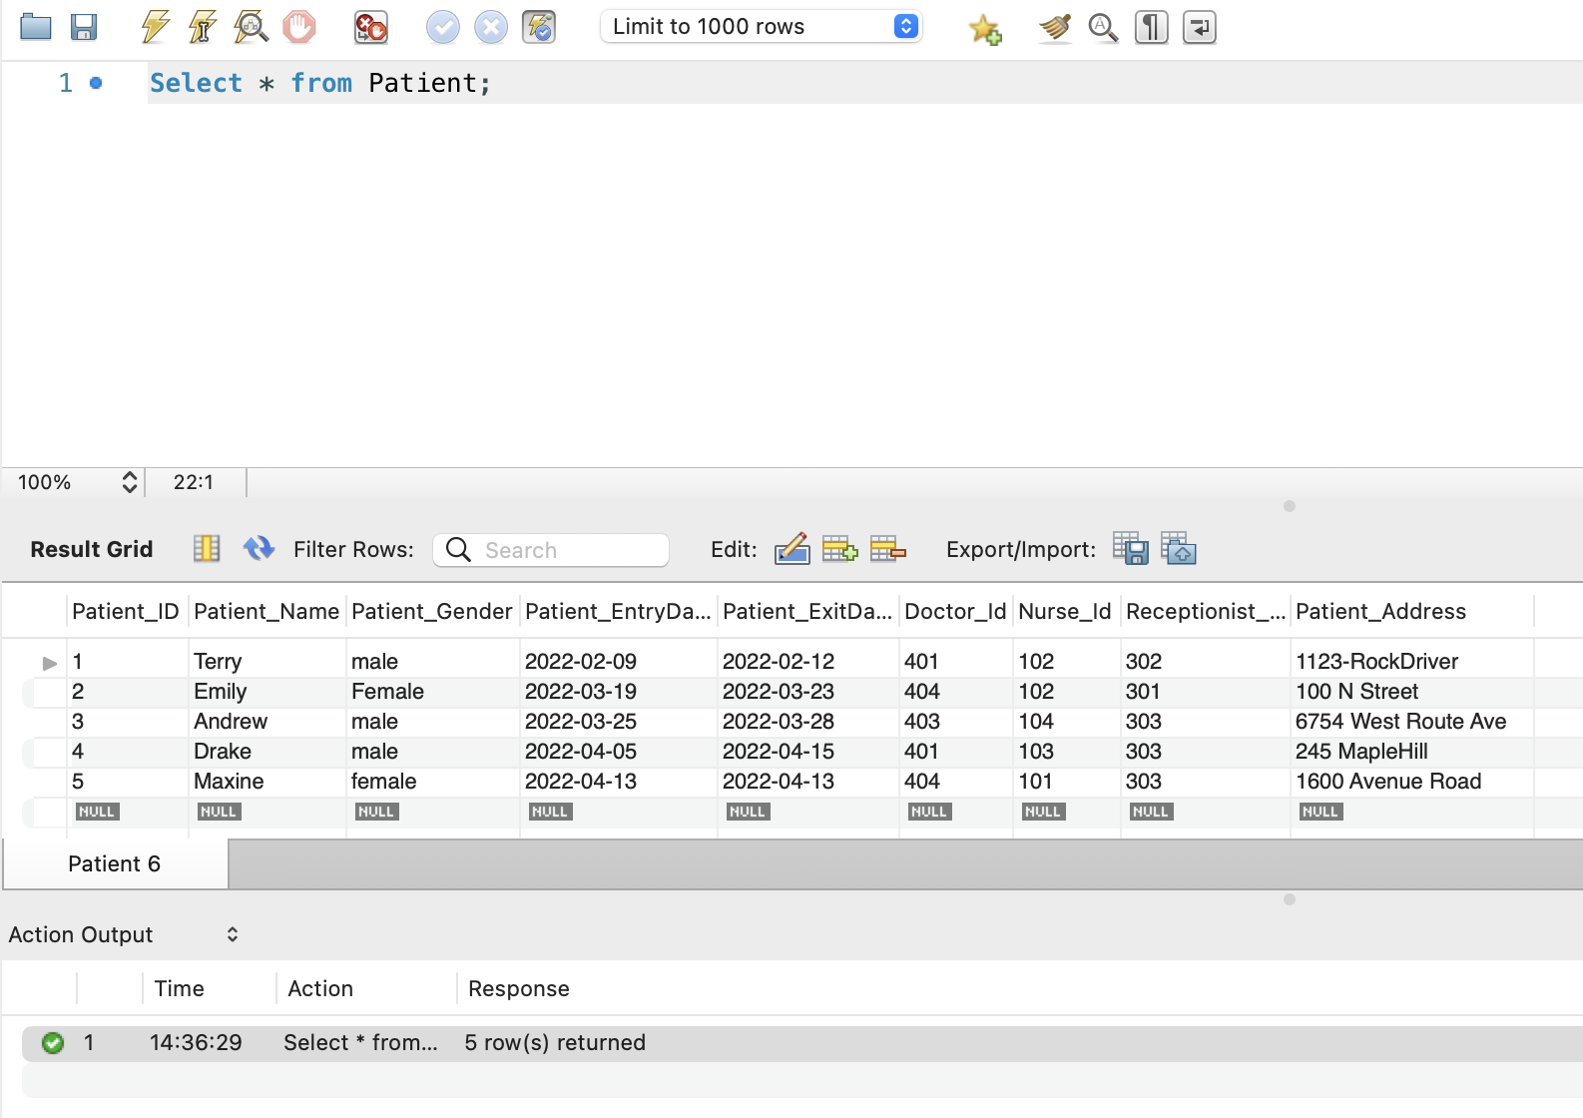

BrokedownTables:

1. Select * from Visit;

Result:

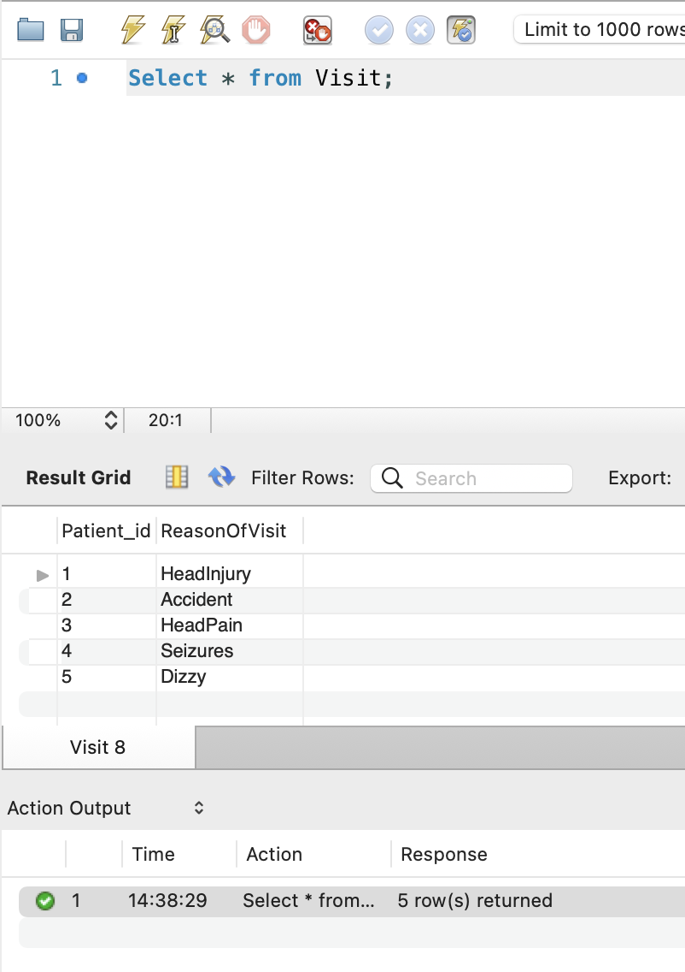

1. Select * from Insurance;

Result:

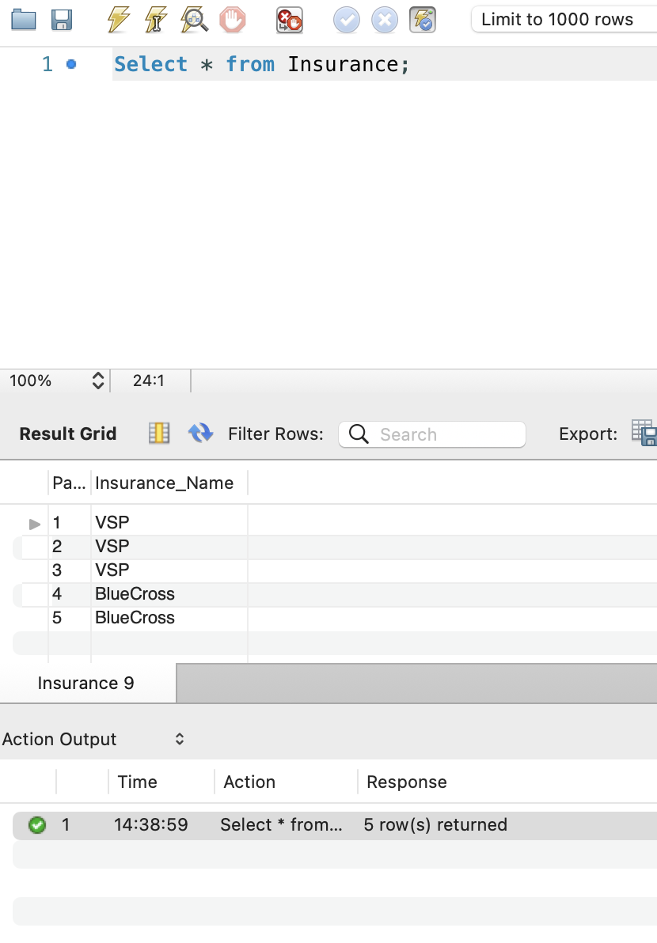

1. Select * from InsuranceInfo;

Result:

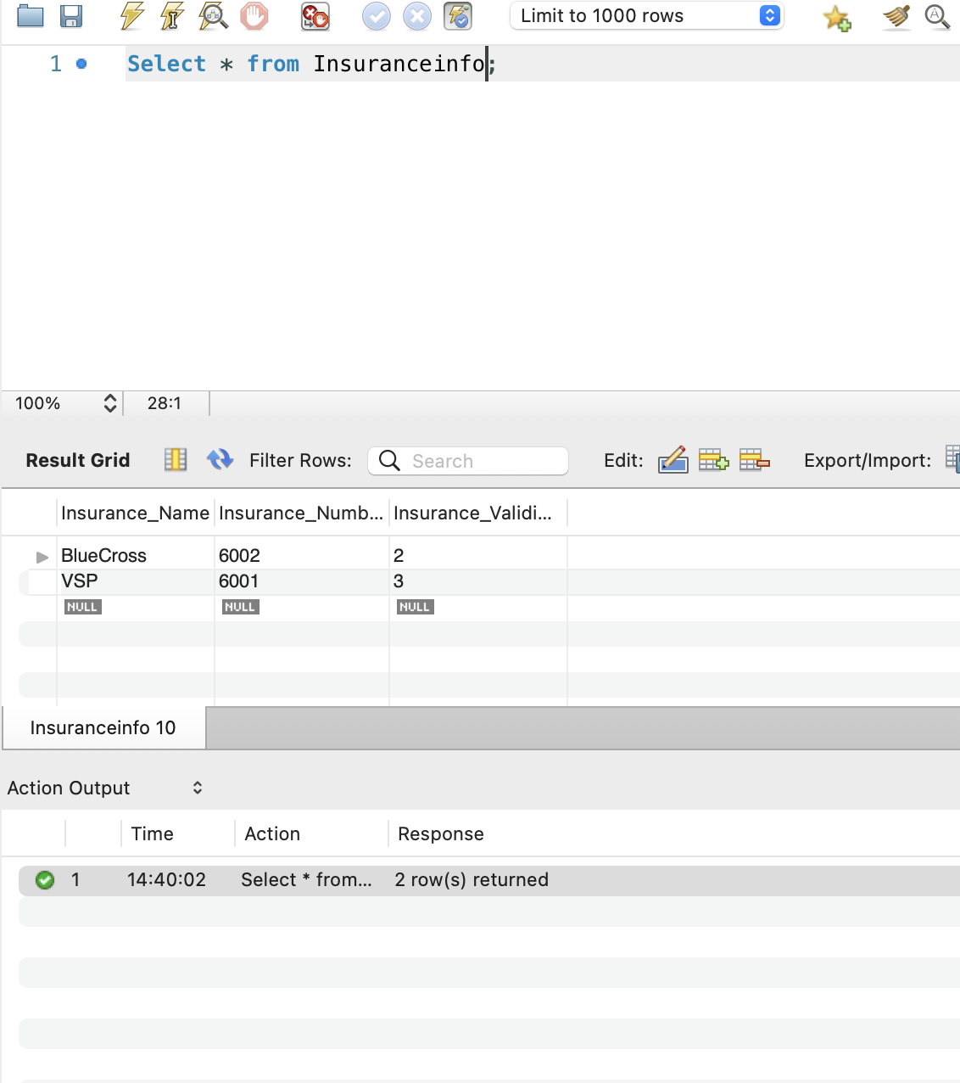

1. Cure:

Result:

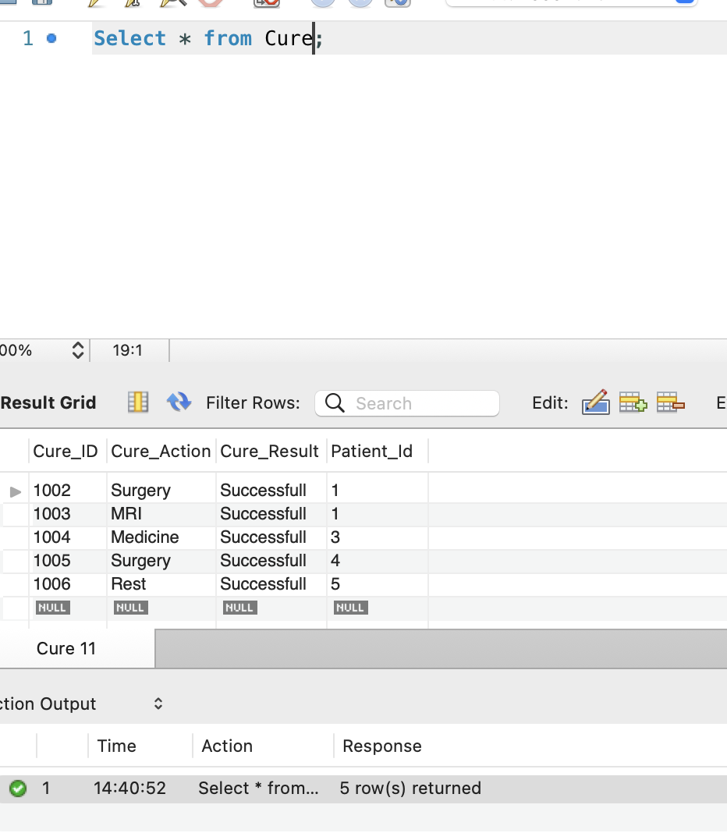

1. Select * from PatientAdmit;

Result:

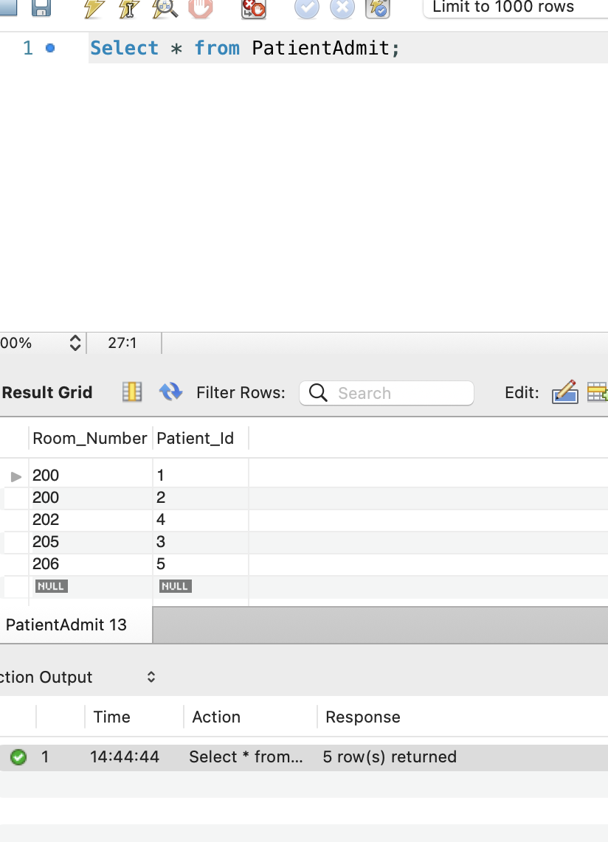

1. Select * from Patient where Doctor_id = '401';

Result:

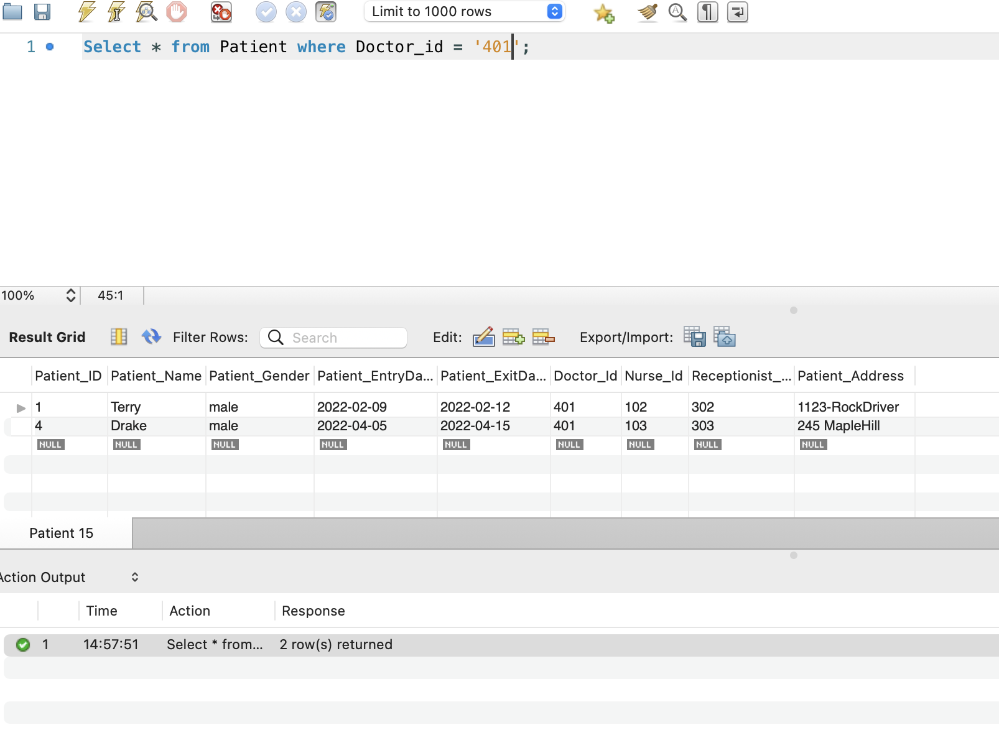

1. Select * from Patient where Nurse_id = '102' and doctor_id = '404';

Result:

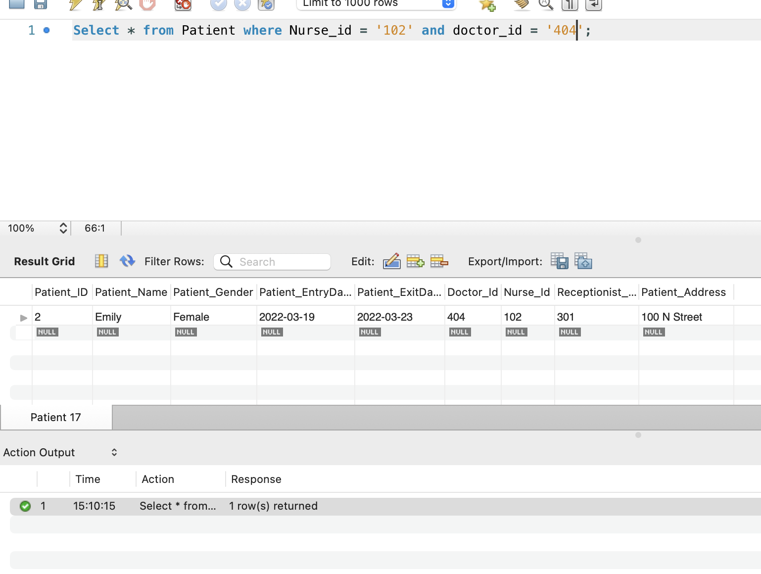

1. Getting names of patient names and why they are in Emargency:

SQL:

Select p.Patient_id,p.Patient_name,v.ReasonOfVisit from Patient p join Visit v

on p.patient_Id = v.Patient_id ;

Result:

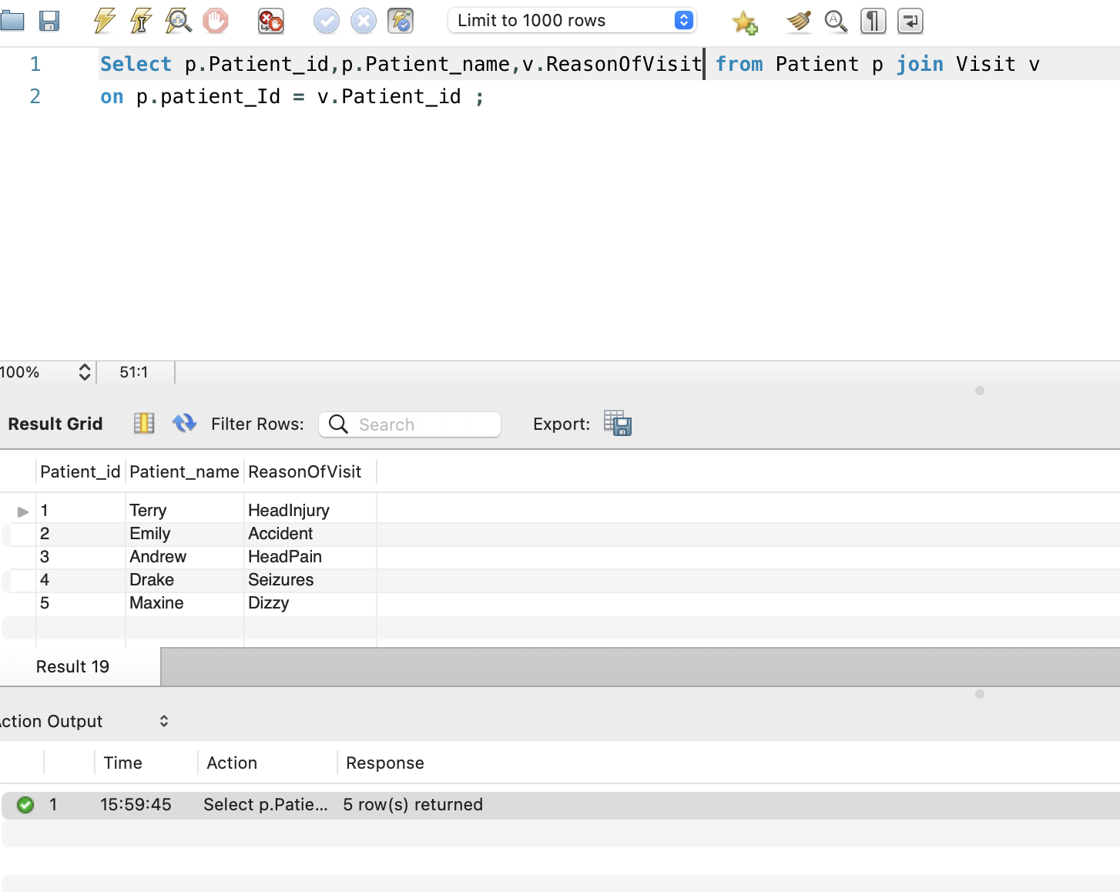

1. Retriving informatin about all patients and their reason of visiting Emargency and doctor the assigned by joining 3 tables(Patient,Visit,Doctor)

SQL:

Select p.Patient_name,v.ReasonOfVisit,d.doctor_Name from Patient p join Visit v

on p.patient_Id = v.Patient_id join doctor d

on p.doctor_id = d.doctor_id;

Result:

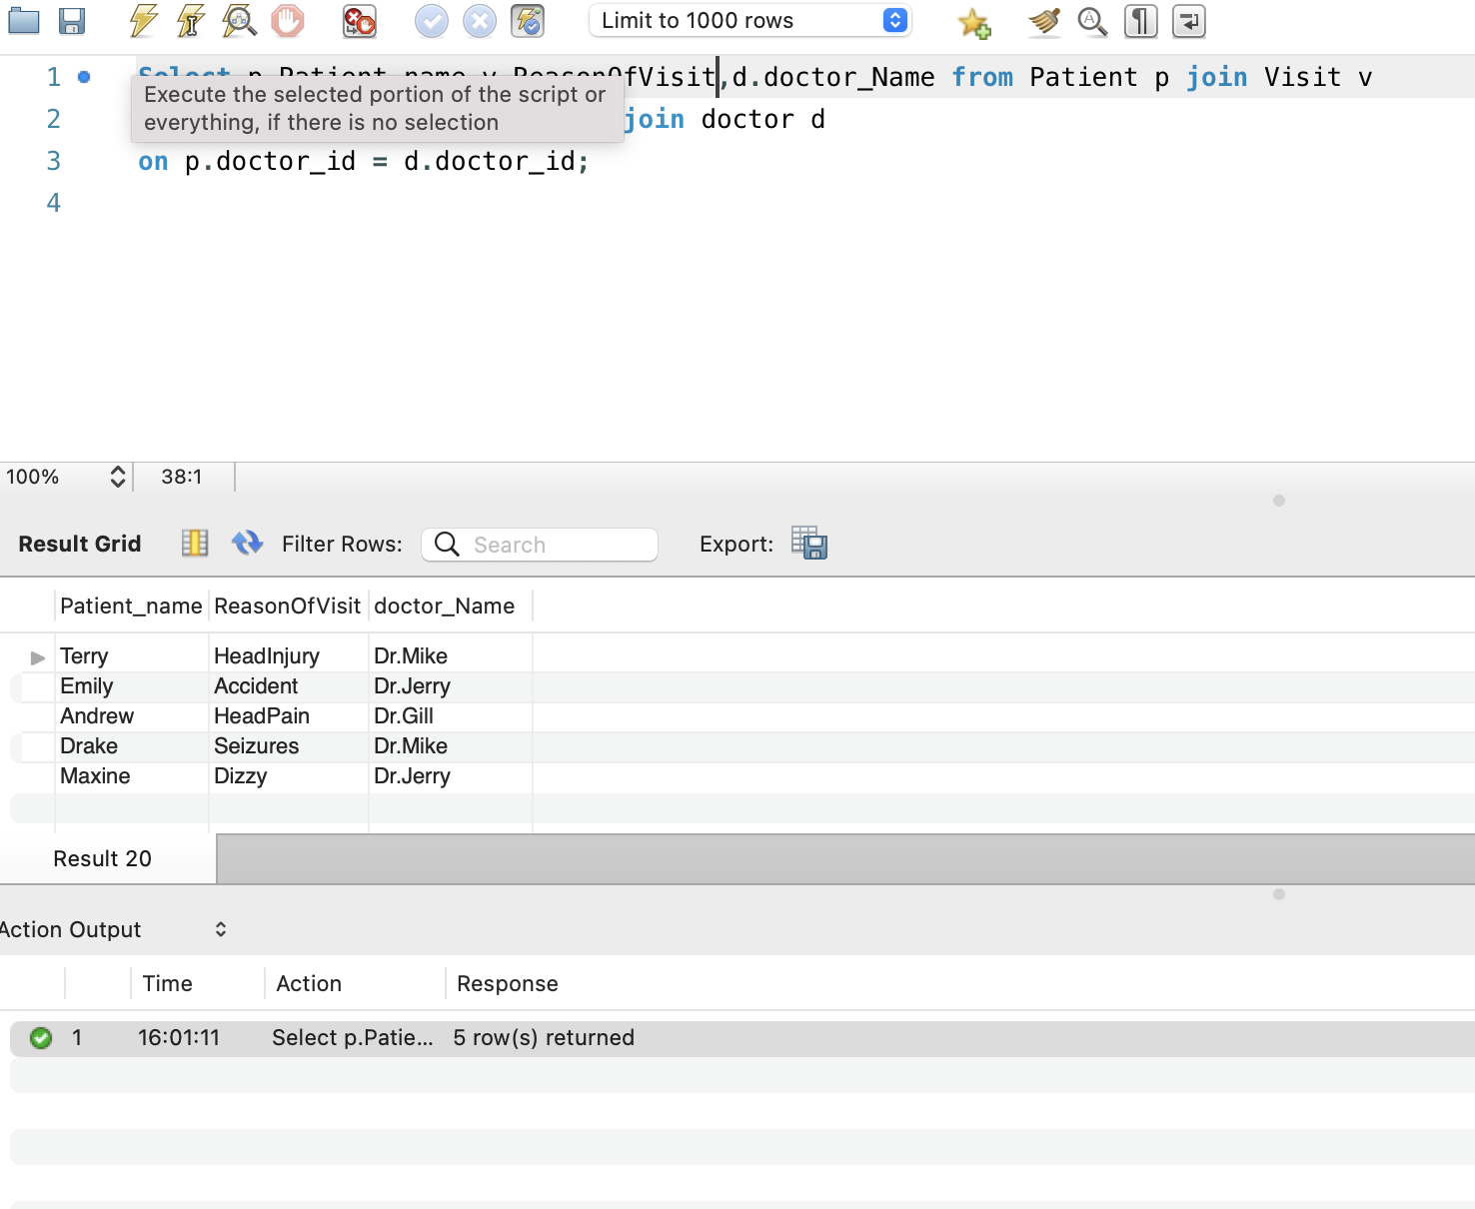

1. Patient who visited Emergency on 25th March 2020

SQL:

Select * from patient where patient_EntryDate = '2022-03-25';

Result:

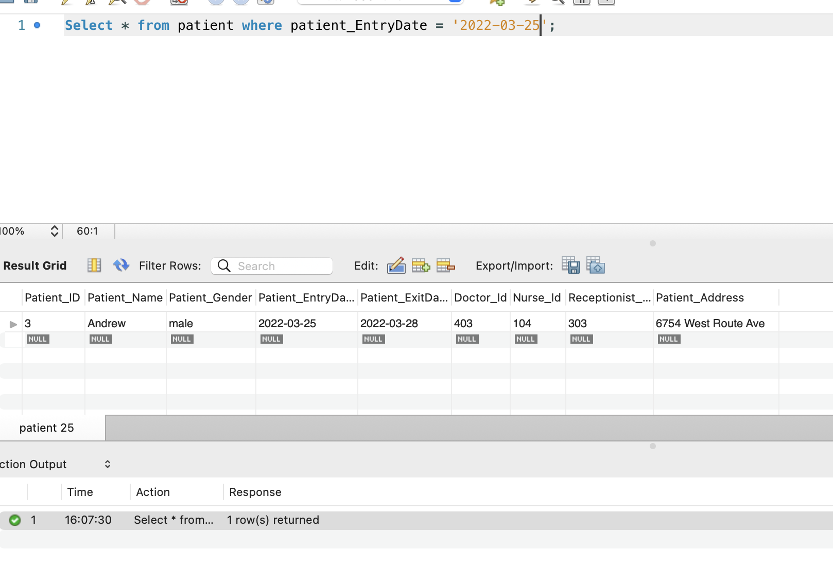

1. Patients Visiting emergency between Mar 19th 2022 to Apr 13th 2022

SQL:

Select * from patient where patient_EntryDate between '2022-03-19' and '2022-04-13';

Result:

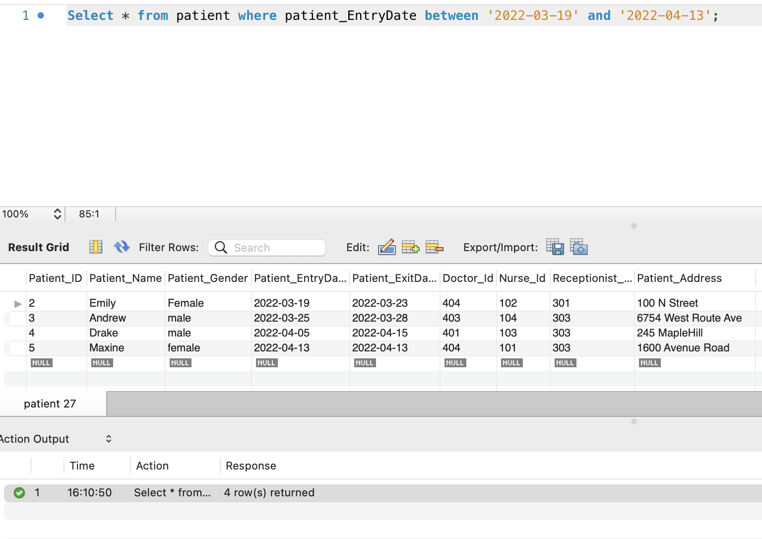

1. Updating Patient “Andrew” Address from ‘6754 West Route Ave’ to ‘2390 JhonsonRoad’

SQL:

update patient set Patient_Address = '2390 JhonsonRoad' where patient_Id = '3'

Result:

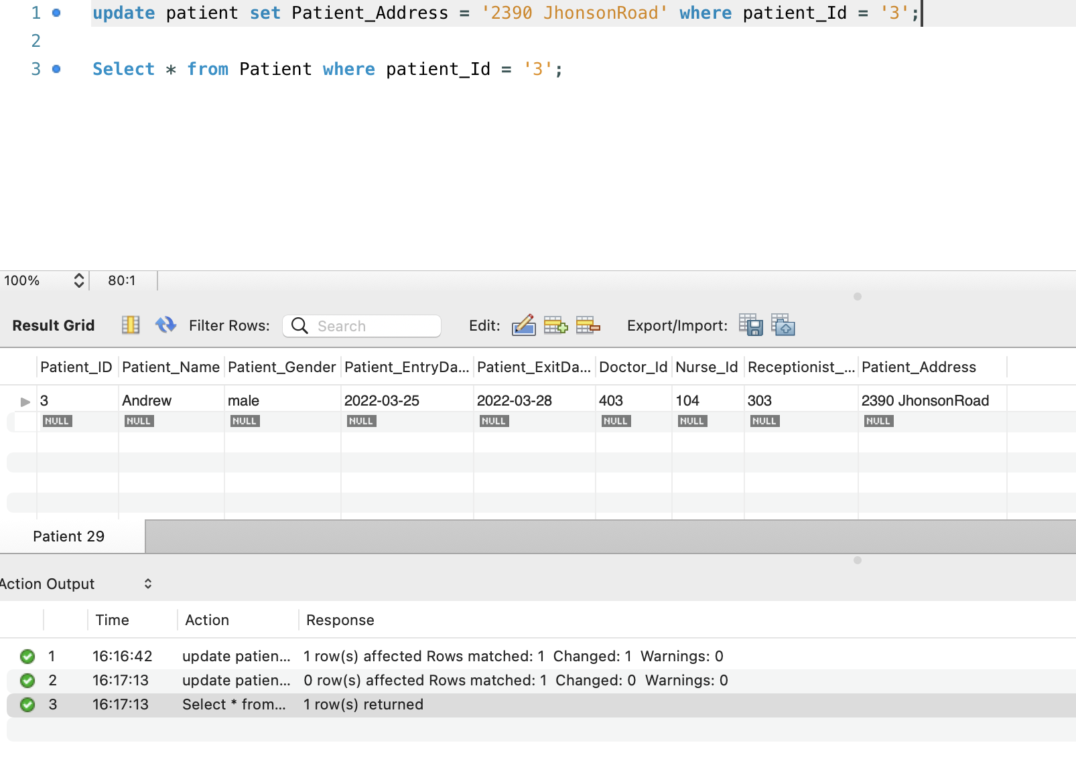

Added more patients to patient table:

SQL:

INSERT INTO patient (Patient_ID,Patient_Name,Patient_Gender,Patient_EntryDate,Patient_ExitDate,Doctor_Id,Nurse_Id,Receptionist_Id,Patient_Address)

values ('06','Rockey','male','2022-04-13','2022-04-16','404','105','304','824 Hillroad'),

('07','Richi','female','2022-03-19','2022-03-24','403','101','301','1 West Road'),

('08','Milli','Female','2022-04-28','2022-04-30','402','105','302','520 MountainHills'),

('09','Haley','female','2022-02-09','2022-02-12','404','103','305','1432 PeerRoad'),

('10','Haley','female','2022-05-03','2022-05-06','405','105','304','786 MathewHill');

Select * from patient;

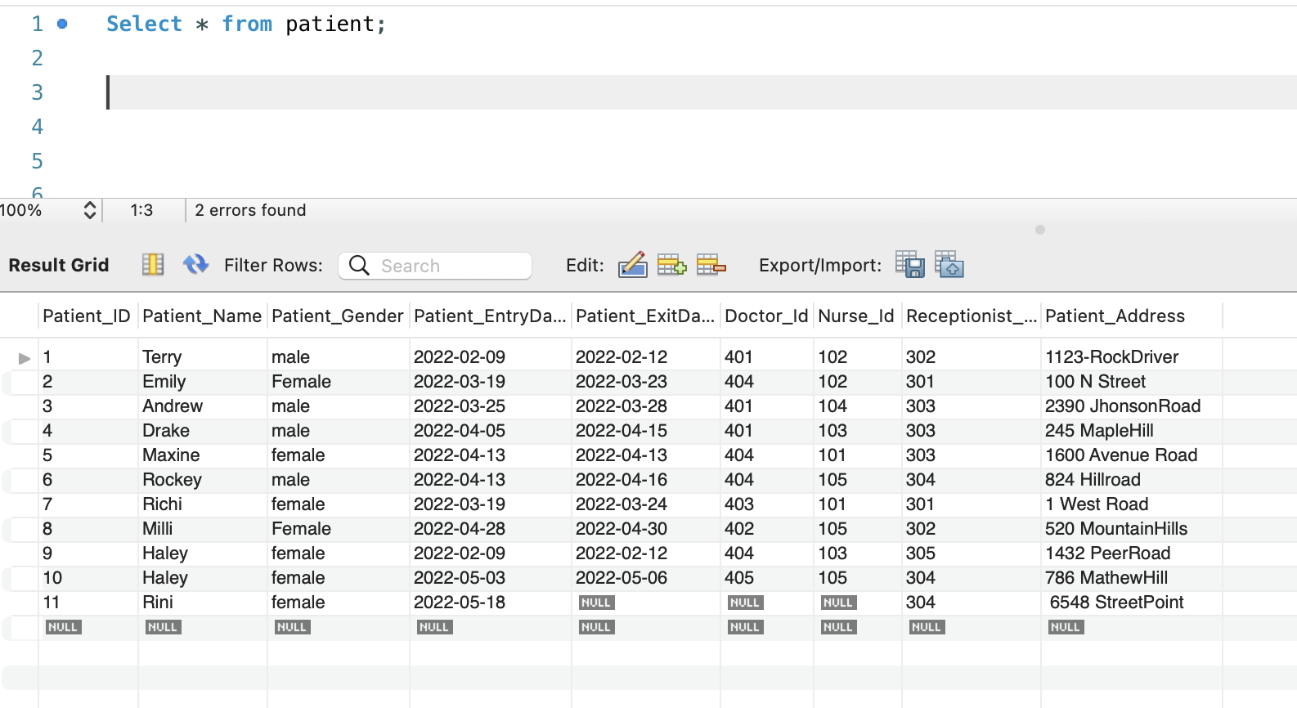

1. Male Patients visited to emergency

SQL:

Select * from patient where patient_gender = ‘male’;

Result:

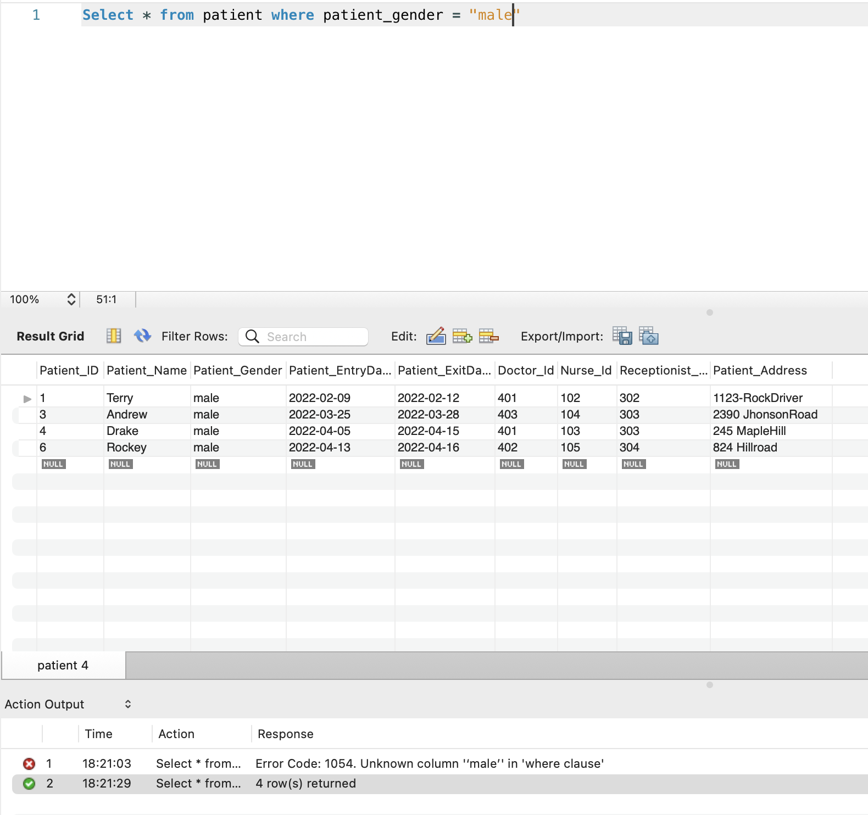

1. Patients who stay in room number 200:

SQL:

select patient_id,patient_name from patient

where patient_id in

(select patient_id from patientAdmit where room_number = '200');

Result:

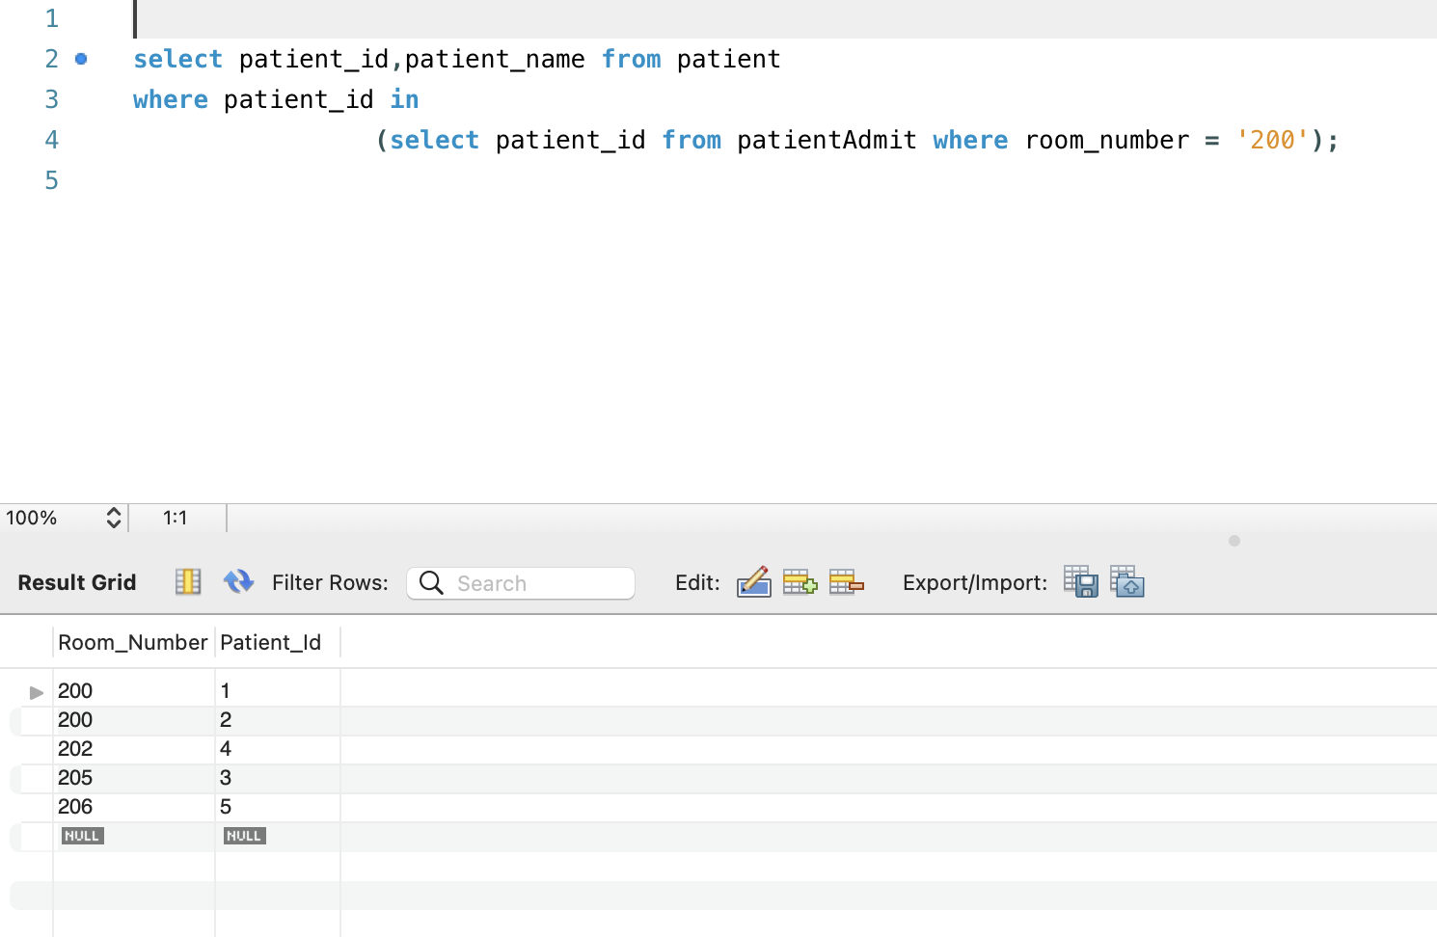

1. Patients who are not in any rooms in emergency:

SQL:

select patient_id,patient_name from patient

where patient_id not in

(select patient_id from patientAdmit );

Result:

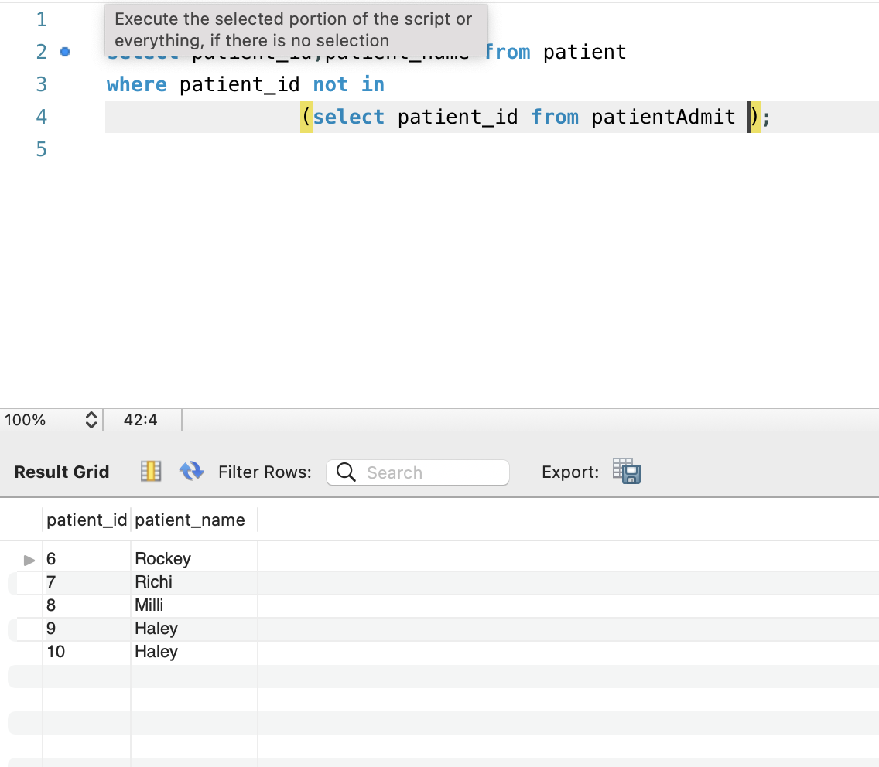

1. Which doctor available on April 13th 2022

SQL:

Select * from doctor where dr_availabilityStatus = 'yes' and dr_availabilitydate = '2022-04-13';

Result:

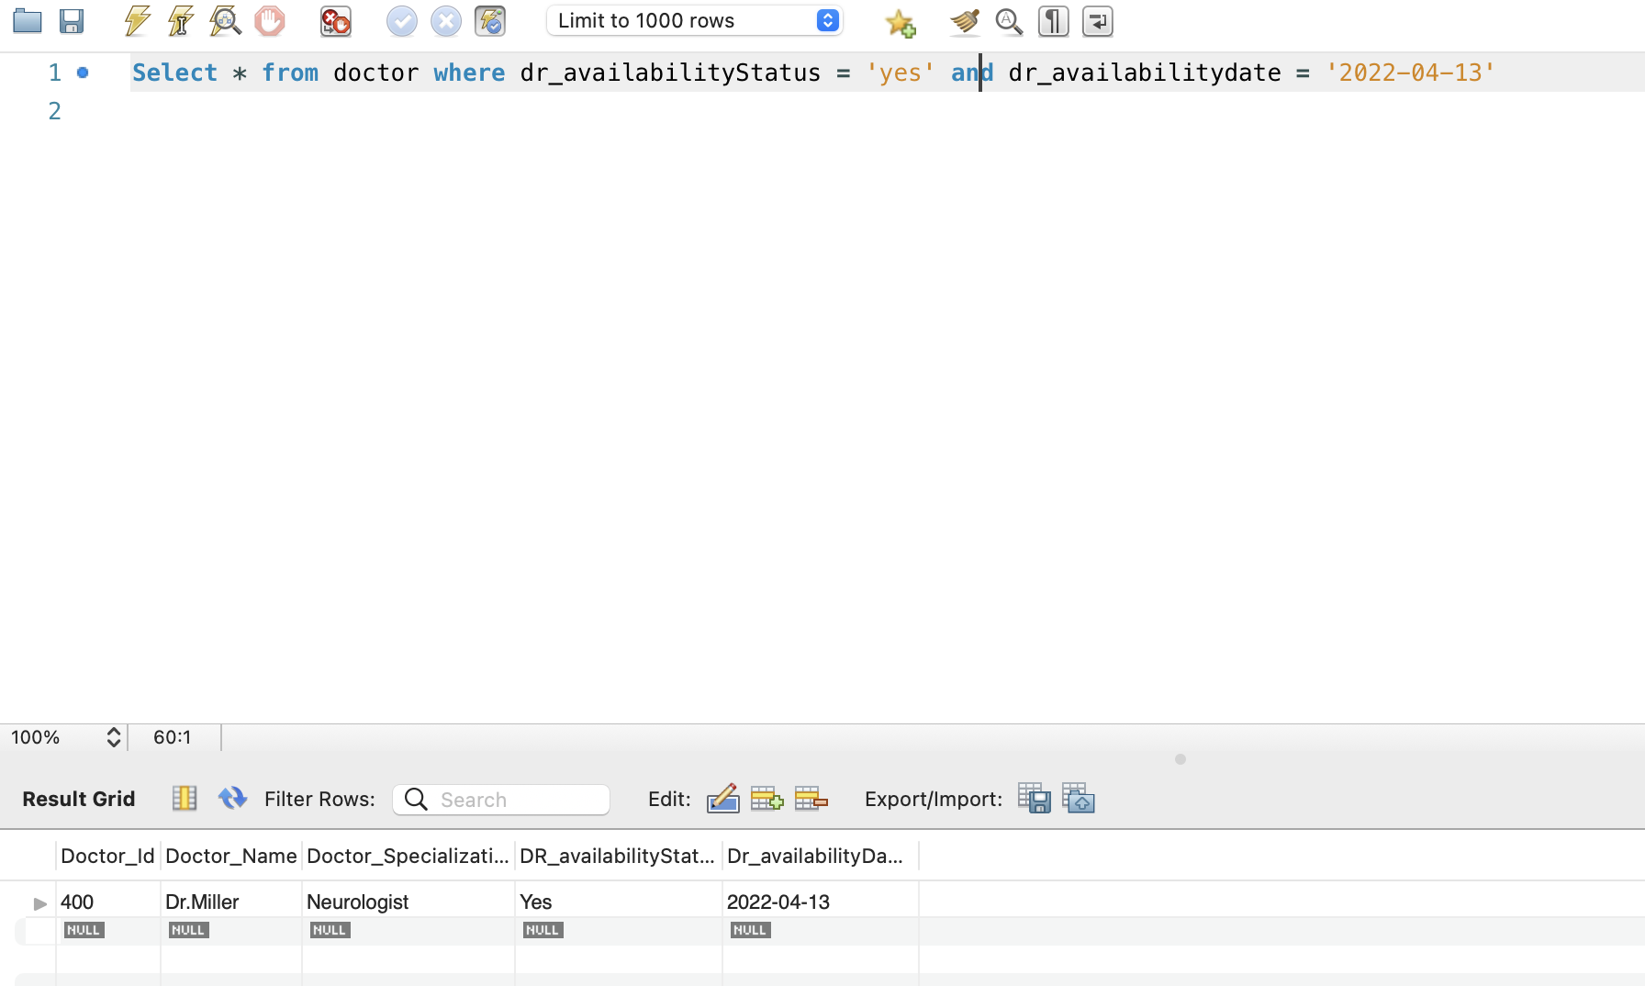

1. Doctors who are Neurologists:

SQL:

Select * from doctor where Doctor_Specialization = 'Neurologist'

Result:

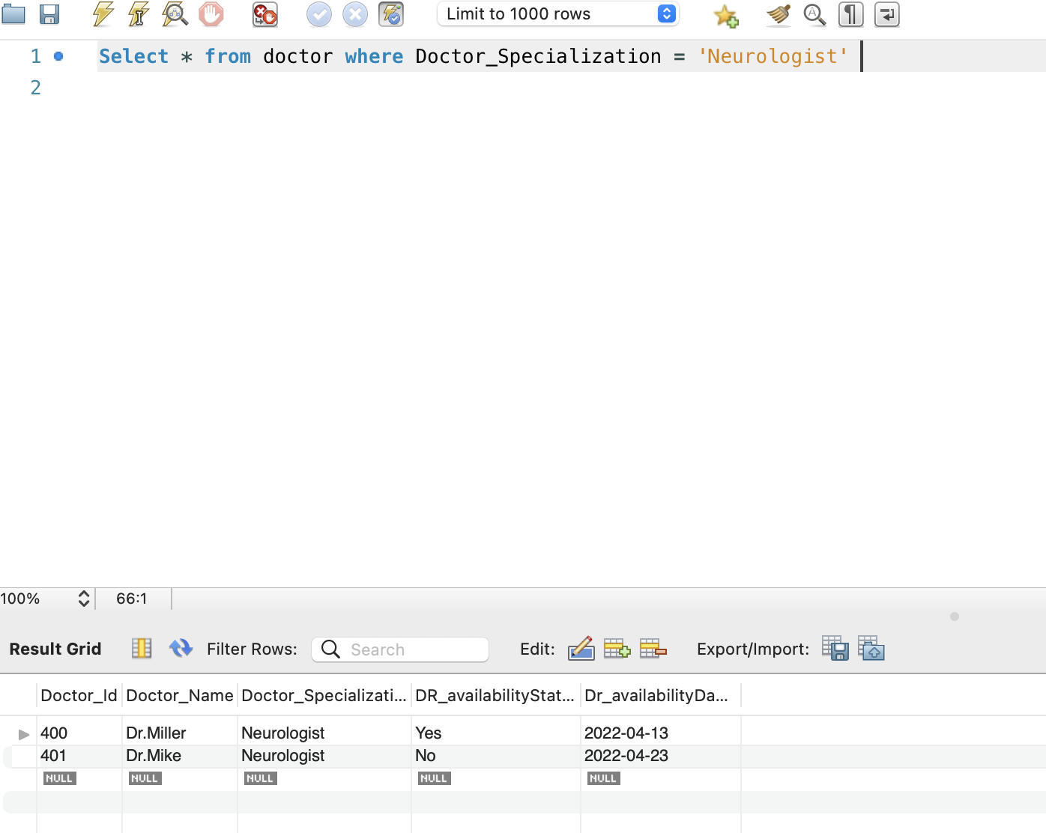

1. List of Patients why they are in emergency and their symptoms, which doctor is handling

SQL

Select p.Patient_Name,v.Reasonofvisit,v.Symptoms,d.Doctor_specialization,d.Doctor_Name

from patient p join visit v

on p.patient_id = v.patient_id join doctor d

on p.doctor_id = d.doctor_id

Result:

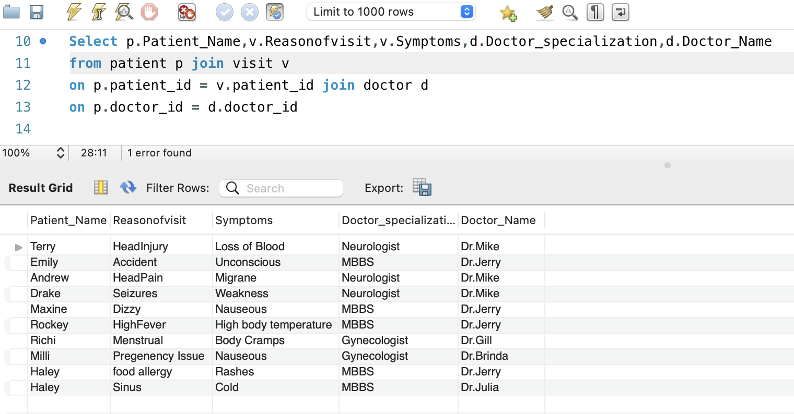

1. Patient, their symptoms and cure they got

SQL:

Select p.Patient_Name,v.Reasonofvisit,v.Symptoms,c.cure_Action,c.Cure_Result

from patient p join visit v

on p.patient_id = v.patient_id join cure c

on p.patient_id = c.patient_id;

Result:

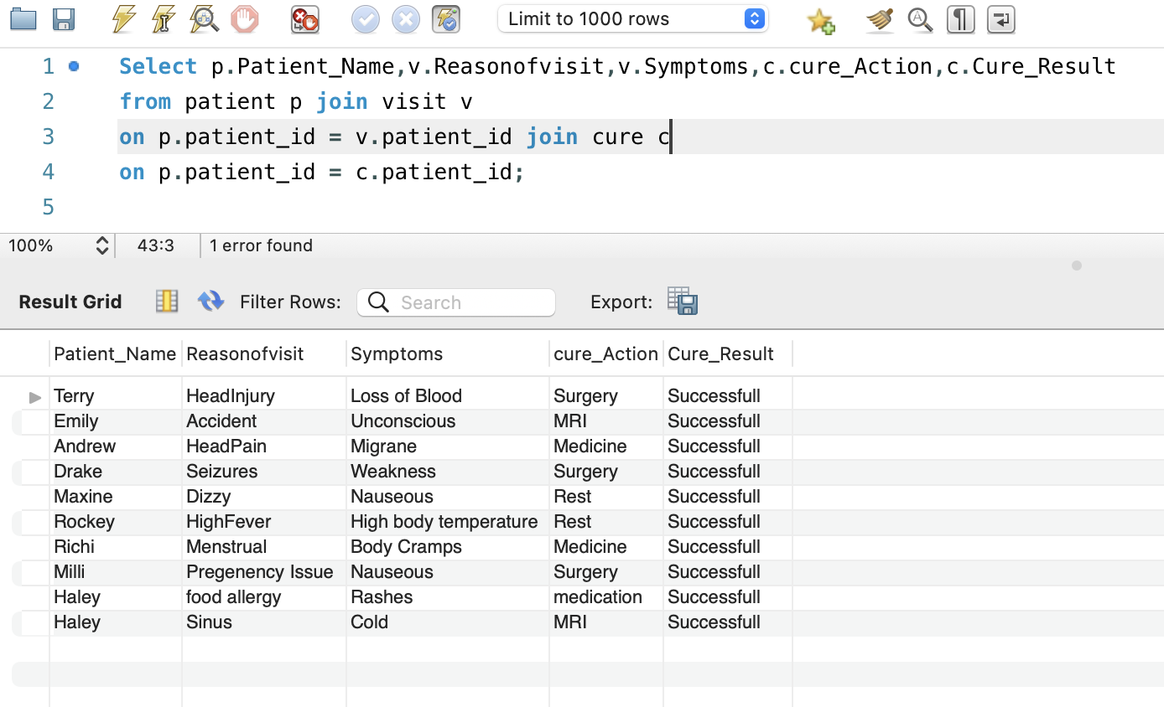

1. Patients and their Insurance Provider:

SQL:

select i.Patient_id,i.Insurance_Name,n.Insurance_Number,n.Insurance_Validity

from Insurance i join InsuranceInfo n

where i.Insurance_name = n.Insurance_name

Result:

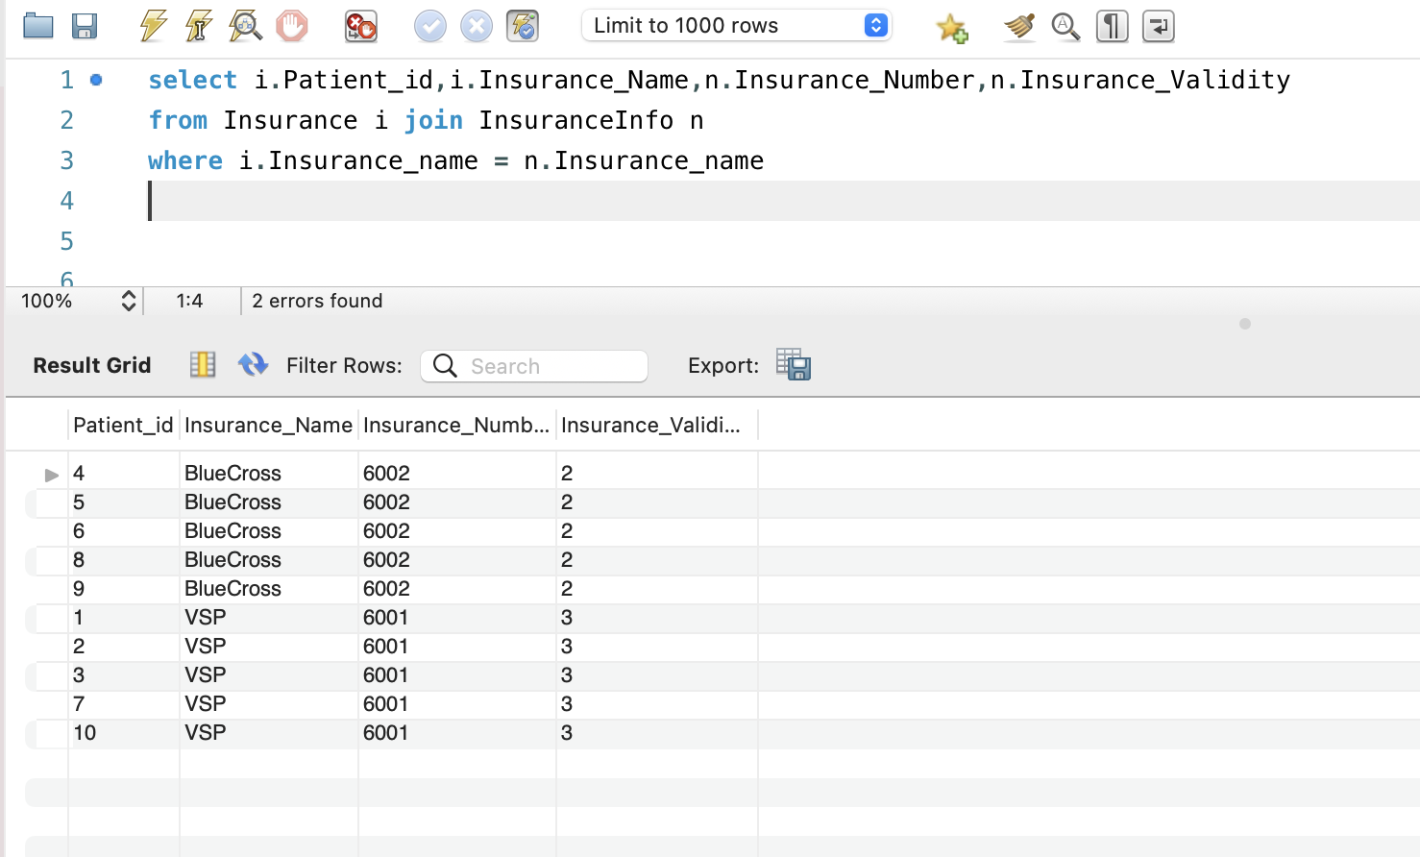

1. Patients whom doctors are not assigned waiting to get assign:

SQL:

Select * from Patient where doctor_id is null

Result:

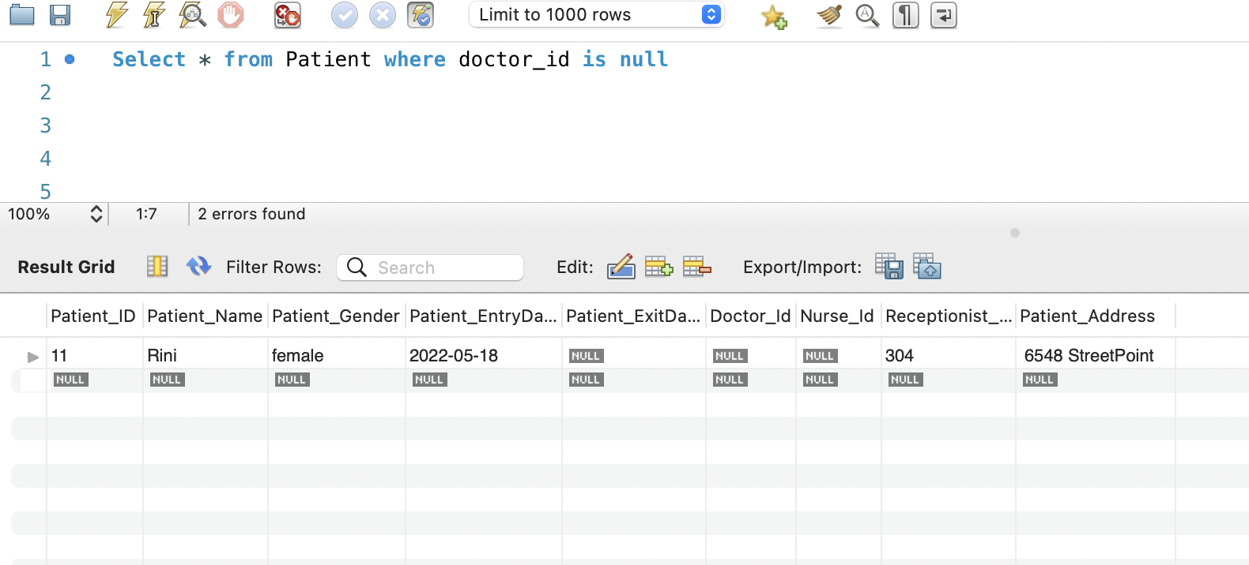

1. Checking how many rooms are available:

SQL:

Select Count(*) as Rooms_Available from room where room_Availability = 'Yes'

Result

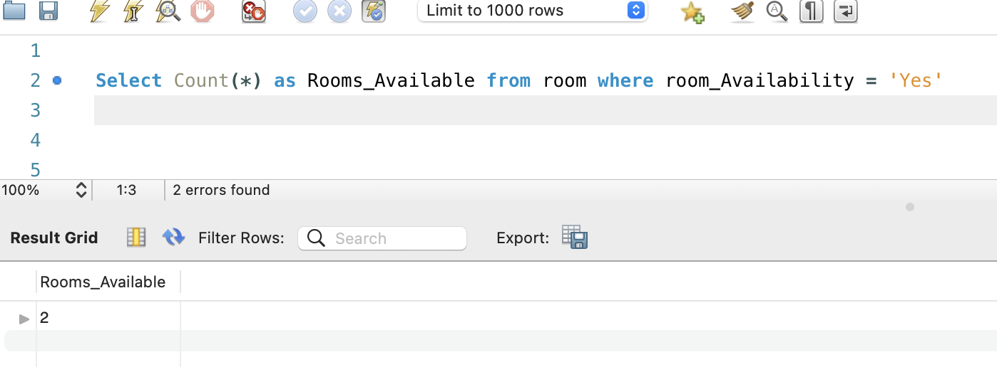

1. Checking how many room are booked:

SQL:

Select Count(*) as Rooms_Available from room where room_Availability = 'No'

Result:

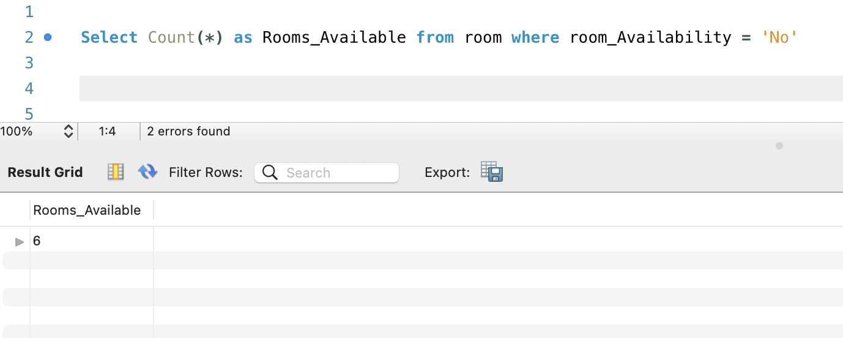

1. Patients who consulted Receptionist id 303:

SQL

select p.patient_Id,p.Patient_Name,r.Receptionist_id,r.receptionist_Name from patient p join receptionist r

on p.Receptionist_id = r.Receptionist_id

where r.receptionist_id = '303'

Result:

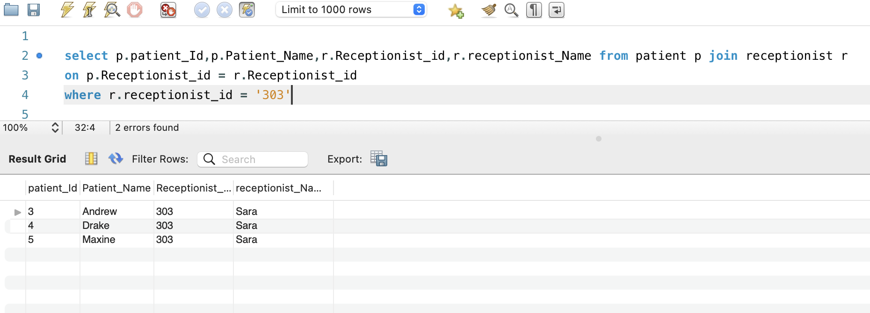

1. Patient who approached receptionist 303(Sara) and their assigned doctors:

SQL:

Select n.Patient_Name,n.Receptionist_Name,d.doctor_Name from (select p.patient_Id,p.Patient_Name,p.doctor_id,r.Receptionist_id,r.receptionist_Name

from patient p join receptionist r

on p.Receptionist_id = r.Receptionist_id

where r.receptionist_id = '303') n join doctor d on

d.doctor_id = n.doctor_id

Result:

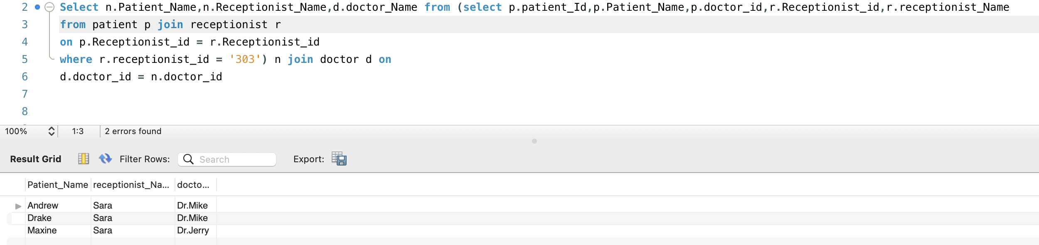

1. Patients with symptoms nauseous

SQL:

Select p.Patient_id,p.patient_name,v.symptoms from patient p join visit v

on p.patient_id = v.patient_id

where symptoms = 'nauseous';

Result:

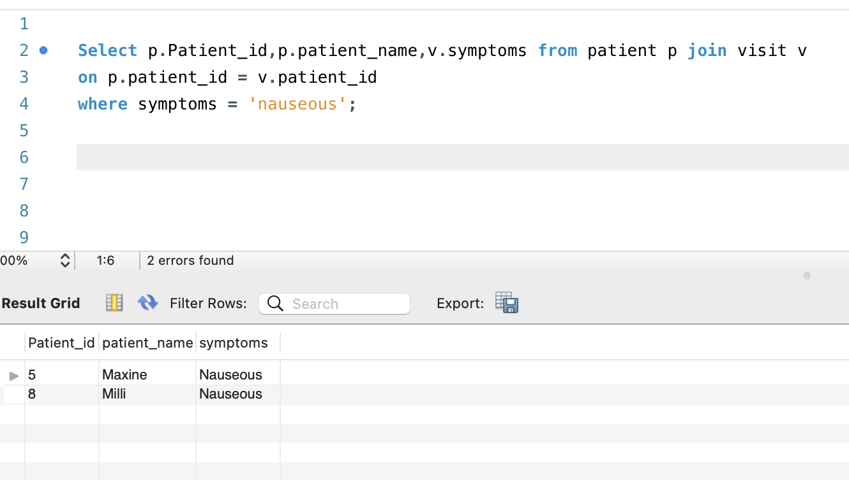

1. Select * from patient where patient_id = '5'

Result:

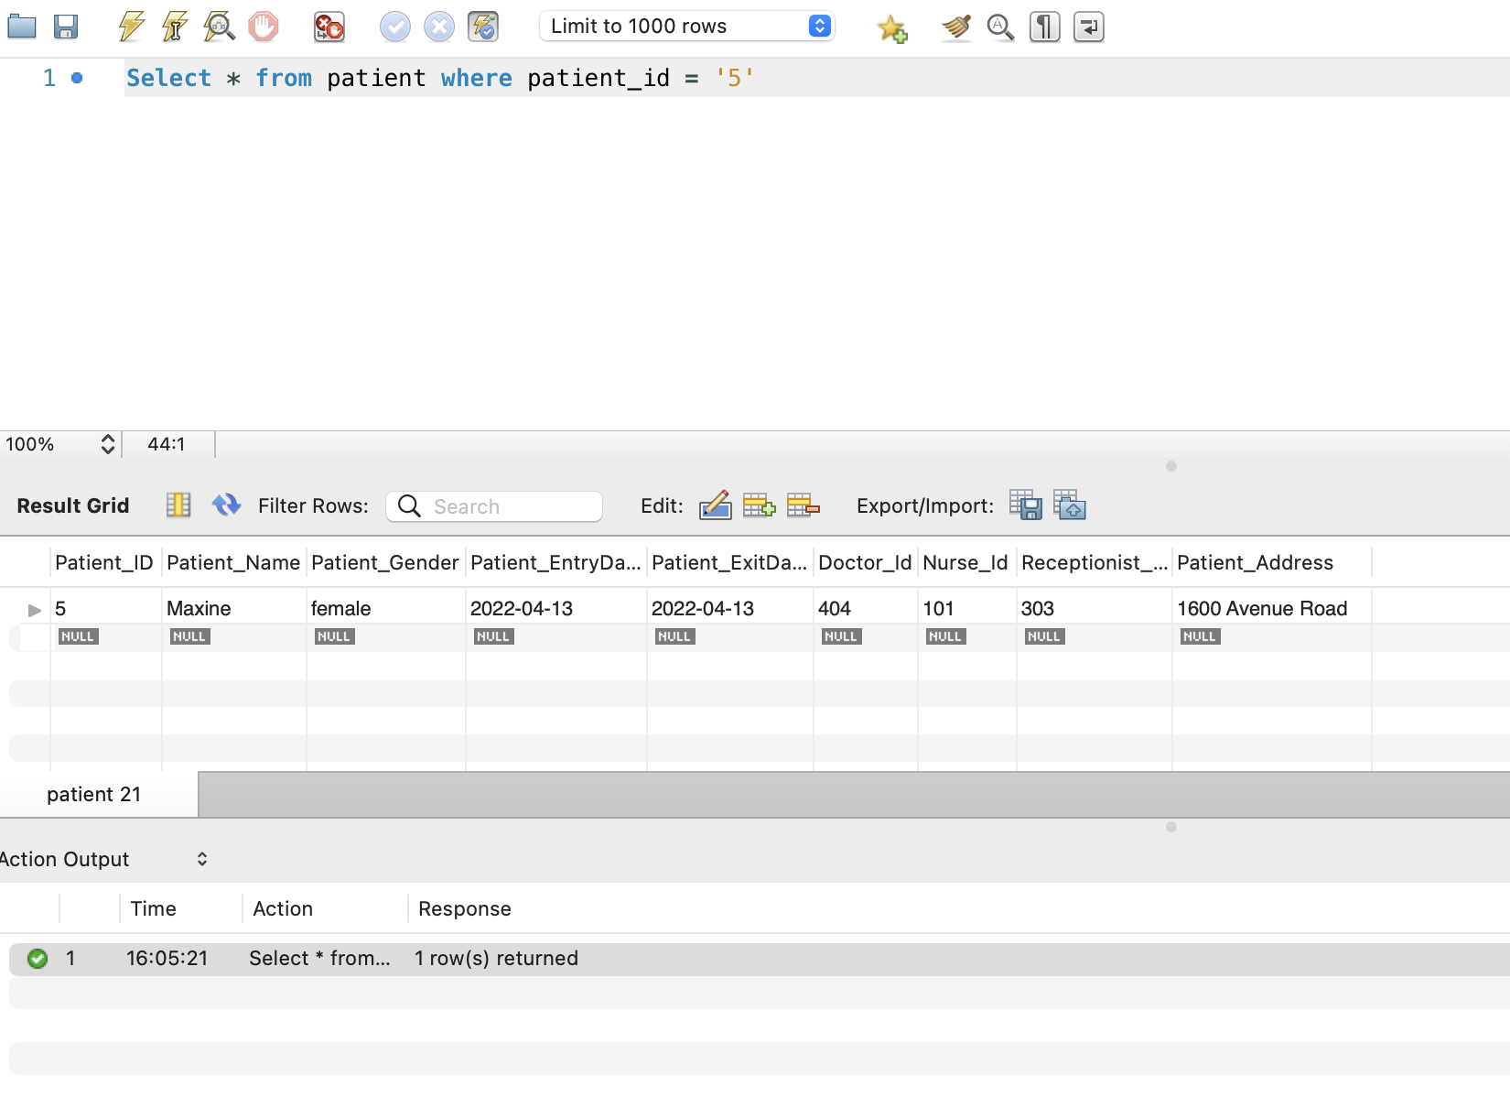

Payment table queries:

1. select max(Bill_Amount) from payments;
2. select min(Bill_Amount) from payments;
3. select sum(Bill_Amount) from payments;
4. select Avg(Bill_Amount) from payments;
5. find out patient which are present in room (patientAdmit)

SQL:

select a.Patient_id

from patientAdmit a

where a.patient_id in (Select p.patient_id from patient p where p.patient_id is not null);

Result:

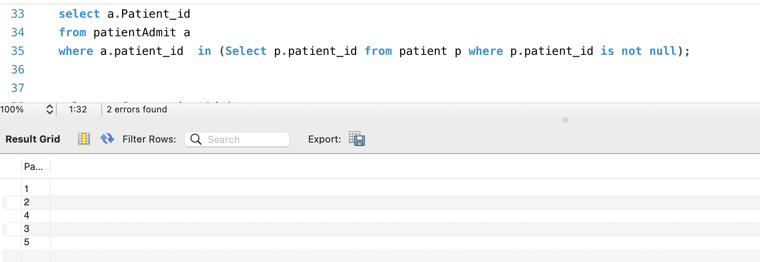

1. Patient with bill amount greater than 500

SQL:

select p.patient_id,p.patient_name,a.Bill_amount from patient p join payments a

on p.patient_id = a.patient_id

where a.bill_amount > 500

order by a.bill_amount desc;

Result:

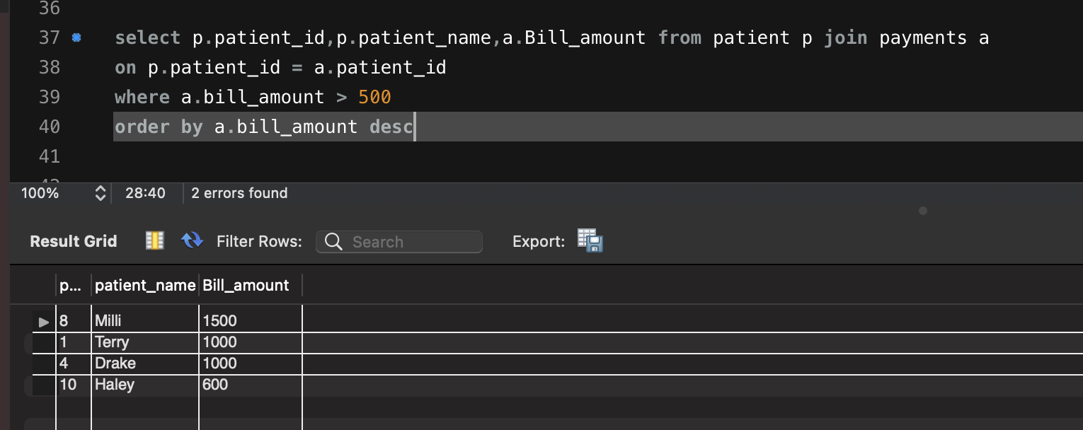

After adding more entries to payment table:

1. Addidng all bills paid by patients:

SQL:

select p.patient_id,p.patient_name,sum(a.Bill_amount) as Total from patient p join payments a

on p.patient_id = a.patient_id

group by p.patient_id,p.patient_name

Result:

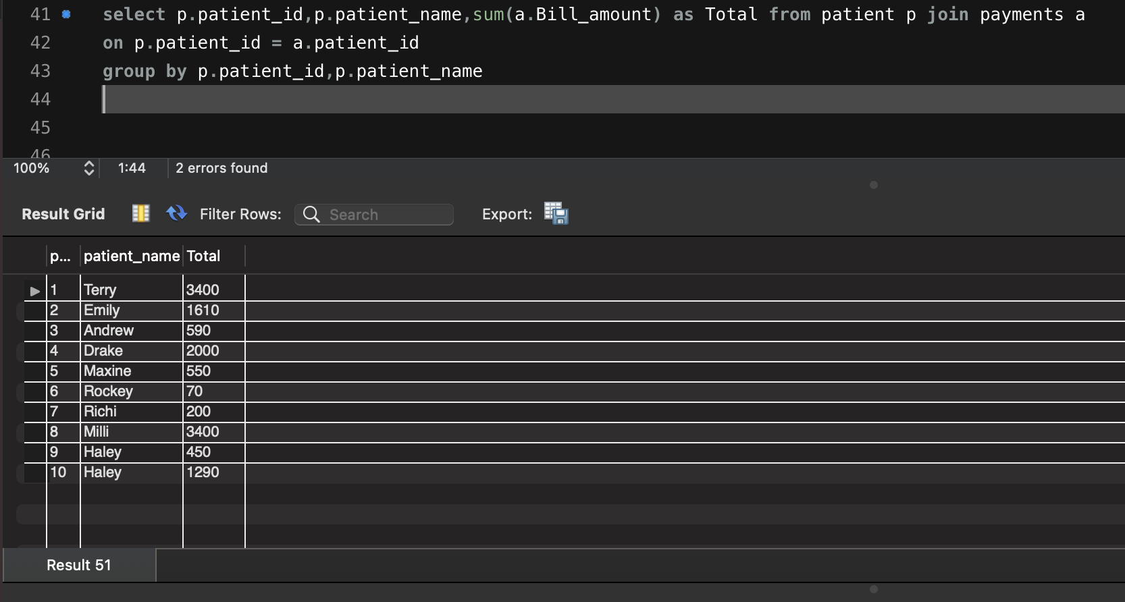

# Section 6: ER Diagram

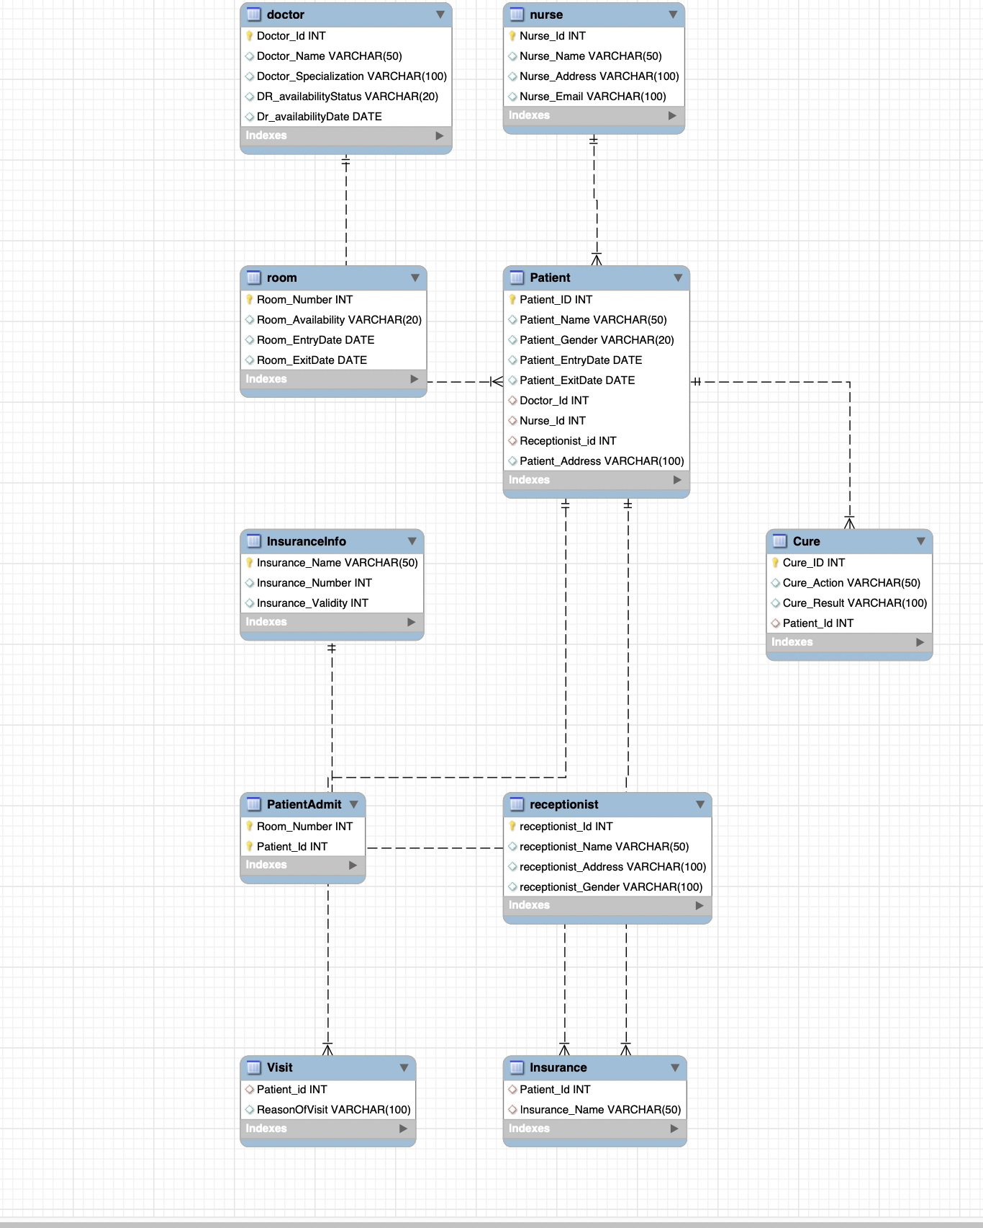

# Section 7: Tool used :

1. MySql Workbench for writing SQL queries
2. Lucid Chart for drawing UML Diagram
3. Word for documentation